A

Project Report

on

**Online Medical Store**

Developed at

**Neeasoft IT Services Pvt .Ltd.**

**Surat – 395001, Gujarat, India**

Developed by

**Vijeet Sharma – Department of IT, DD University**

**Guided By**

**Internal Guide: External Guide:**

**Prof. Vimal Vachhani Mr Neel Gupta**

**Department of Information Technology CTO**

**Faculty of Technology Neeasoft IT Services**

**DD University Pvt .Ltd.**



**Department of Information Technology**

**Faculty of Technology, Dharmsinh Desai University**

**College Road, Nadiad-387001**

**April - 2018**

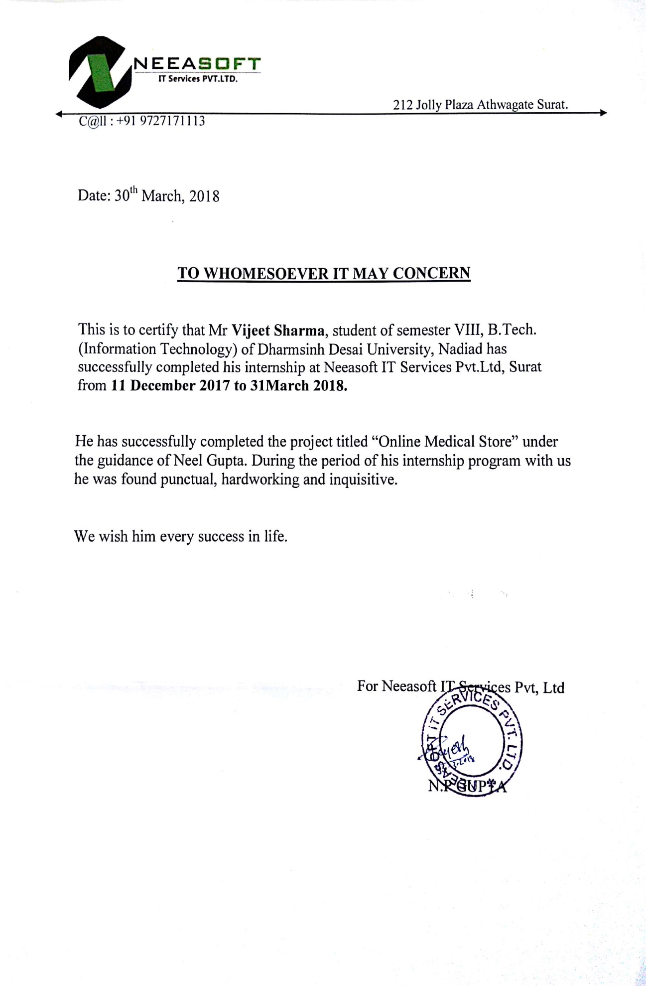

**CANDIDATE’S DECLARATION**

I declare that final semester report entitled “Online Medical Store” is my own work conducted under the supervision of the external guide Mr Neel Gupta from Neeasoft IT Services Pvt .Ltd.

I further declare that to the best of my knowledge the report for B.Tech Final semester does not contain part of the work which has been submitted for the award of B.Tech Degree either in this or any other university without proper citation.

Also I declare that following students also worked in this project:

Candidate’s Signature

Candidate’s Name: Vijeet Sharma

Branch: IT Student ID: 14ITUOS052

## **DHARMSINH DESAI UNIVERSITY**

## **NADIAD-387001, GUJARAT**



## **CERTIFICATE**https://docs.google.com/drawings/d/sHWEXaJVKPw4ytNuEU96tvw/image?w=97&h=13&rev=1&ac=1

This is to certify that the project entitled “Online Medical Store” is a bonafide report of work carried out by Mr. Vijeet Sharma, Student ID no: 14ITUOS052 f Department of Information Technology, semester VIII, under the guidance and supervision for the award of the degree of Bachelor of Technology at Dharmsinh Desai University, Nadiad (Gujarat). He was involved in Project training during academic year 2017-2018.

Internal Guide:

Prof. Vimal Vachhani

Department of Information Technology,

Faculty of Technology,

Dharmsinh Desai University, Nadiad

Date:

Prof. R.S. Chhajed,

Head, Department of Information Technology,

Faculty of Technology,

Dharmsinh Desai University, Nadiad

Date:

**ACKNOWLEDGEMENT**

It gives me immense pleasure and satisfaction in presenting this report of System Development Project undertaken during the 8th semester of B.Tech. This project work is an integrated effort of all those, concerned through the project whose co-operative and effective guidance helped us to complete this project work.

As it is the first step into our Professional Life, I would like to take this opportunity to express our sincere thanks to several people, without whose help and encouragement, it would be unfeasible for us to carry out the desired work.

I would like to thank to Mr Neel Gupta (Project Guide) for giving me an opportunity to work with one of the most esteemed organization of the world. An enviable work culture and an environment that encourages creativity and innovation have inculcated in us a sense of discipline and perseverance.

From the bottom of our heart, I would like to express my sincere thanks to my Head of Department Prof. R.S. Chhajed and our internal guide Prof. Vimal Vachhani, who gave me a opportunity to undertake such a great challenging and innovative work. I am grateful to them for their guidance, encouragement, understanding and insightful support in the development process.

Finally, I would like to thank to all Neeasoft IT Services Pvt .Ltd. employees, all faculty members of our college, our friends and our family members for providing their support and continuous encouragement throughout the project.

With sincere regards,

Vijeet Sharma

**TABLE OF CONTENTS**

**Title Page number**

Abstract…………………………………………………………………….. i

Company’s profile…………………………………………………………. ii

List of Figures……………………………………………………………… iv

List of Tables………………………………………………………………. v

1. Introduction…………………………………………………………….. 01
   1. Project details………………………………………………….. 01
   2. Purpose…………………………………………………………. 02
   3. Scope…………………………………………………………… 02
   4. Objective……………………………………………………….. 03
   5. Technology and Literature Review…………………………….. 03
2. Project Management………………………………………………….....04
   1. Feasibility Study……………………………………………….. 04
      1. Technical Feasibility……………………………….. 04
      2. Time Feasibility……………………………………. 05
      3. Operational Feasibility……………………………... 05
      4. Implementation Feasibility………………………… 05
   2. Project Planning………………………………………………... 05
      1. Project Development Approach and Justification…. 05
      2. Project Plan………………………………………… 07
      3. Milestones and Deliverables……………………….. 07
      4. Roles and Responsibilities…………………………. 09
      5. Group Dependencies……………………………….. 09
   3. Project Scheduling……………………………………………... 09
      1. Project Scheduling Chart…………………………... 09
3. System Requirements Study…………………………………………… 11
   1. Study of current system………………………………………... 11
   2. Problems and Weaknesses of Current System…………………. 11
   3. User Characteristics……………………………………………. 11
   4. Hardware and Software Requirements………………………… 11
   5. Constraints……………………………………………………... 12
      1. Regulatory policies………………………………… 12
      2. Hardware Limitations……………………………… 12
      3. Parallel Operations…………………………………. 12
      4. Criticality of the application……………………….. 13
   6. Assumptions and dependencies………………………………... 13
4. System Design…………………………………………………………. 14
   1. Requirements of New System………………………………….. 14
      1. User Case Diagram ………………………………... 14
      2. System Requirements………………………………. 15
   2. Features of new system………………………………………… 18
   3. System Activity (Activity Diagram)…………………………… 19
   4. Data Modelling………………………………………………… 20
      1. ER Diagram………………………………………... 20
5. System Design…………………………………………………………. 21
   1. System architecture design…………………………………….. 21
      1. Class Diagram……………………………………… 22
   2. Sequence Diagram……………………………………………... 23
   3. Component Diagram………………………………………….... 24
   4. Deployment Diagram................................................................... 24
6. Implementation Planning………………………………………………. 25
   1. Implementation Environment………………………………….. 25
   2. Modules of Specification………………………………………. 25
   3. Coding Standards……………………………………………….26
7. Testing………………………………………………………………….. 27
   1. Testing Plan……………………………………………………. 27
   2. Testing Strategy………………………………………………... 28
      1. Unit Testing………………………………………... 28
      2. Sub System Testing………………………………... 29
      3. System Testing……………………………………... 29
      4. Acceptance Testing……………………………….... 30
   3. 3Testing Methods………………………………………………. 30
      1. Black Box Testing………………………………….. 31
      2. White Box Testing…………………………………. 31
      3. Design of Test Cases……………………………….. 32
   4. Test Cases……………………………………………………… 32
8. User Manual……………………………………………………………. 35
9. Limitation and Future Enhancement…………………………………… 55
   1. Limitation……………………………………………………… 55
   2. Future Enhancement…………………………………………… 55
10. Conclusion…………………………………………………………. 56
    1. Conclusion…………………………………………………. 56
    2. Discussion………………………………………………….. 56
       1. Self-analysis and project viability…………………. 56
       2. Problem encountered………………………………. 56
       3. Summary of project work………………………….. 57

References………………………………………………………………….. 58

Experience…………………………………………………………………..59

|  |
| --- |
| **ABSTRACT**  This work is based on the development of an Online Medical Store. This paper showcases the development of an interactive android application which functions as an Online Medical Store System for customers to effortlessly purchase medicines in some clicks. It is an online application through which customers can view available medicines and buy them. The Online Medical Store is the online service which will automate the process of purchasing medicines and will facilitate both the client and the admin with reduced time and efforts. A computer based management system is designed to handle the entire primary information required to manage the whole data. There is also an administrator that would be responsible for approving customer’s purchases, managing products, viewing products, customer’s records. This project intends to introduce more user-friendly approach in the various activities such as record updating, maintenance, and searching.  We have categorised the medicines into prescribed and non-prescribed medicines to avoid the much confusion among customers but the customers have to upload the prescription for the prescribed medicines. The customer can also use the valid promo codes while purchasing medicines which may be profitable to them. Customers will also be notified when there will be new offers. This project will be developed on Android platform. |

**COMPANY PROFILE**

**Neeasoft IT Services Pvt .Ltd.**



Neeasoft IT Services Pvt.Ltd. is a company providing professional-level software development, website development, web designing, application development, digital marketing. They have website programmer for web design, manage, build and maintain high quality solutions for a wide range of businesses.

They have built business by working with clients to ensure the solutions they develop are profitable for them. Their forte is to take the software development, website development requirement, apply the understanding of web and software development methodologies and propose innovative & technical features and site enhancements that helps achieve goals - while taking into account commercial considerations & timeframe with high level of communication and support. Businesses as well as users have become more dynamic and reactive in their thinking because of the website, they expect to see up to date information immediately and in very proper manner. By choosing Neeasoft IT Services Pvt.Ltd. website development services, you get more than our software programming, design and development work.

You also get our years of experience and expertise, in developing a Web site or Application unique to your business needs for PHP website development. Neeasoft IT Services Pvt .Ltd. is an innovative technology industry focused, business driven professional custom PHP website development services firm. From web design and PHP web application development to custom applications, our talented developer work intelligently to solve and manage client’s needs and requirements. We custom PHP website development serves to deliver cost effective interactive technology and design solutions without compromising on quality. With clients globally, custom PHP website developer’s produces innovative, high-performance Web sites for companies in multiple industries including hospitality, retail, wholesale, communication and so on. Using the latest programming and design, Neeasoft IT Services Pvt .Ltd. creates the optimal, effective online as well as desktop experience for every client. Custom website development can work within your existing corporate ID or create one for you to establish a sense of branding for your need. The quality of custom website development, designs and programming is evident in the Web sites and web applications we create. Our commitment to quality designs, superior technology enhancement and customer service is paramount.

Satisfying the client is fundamental to our business and has been the leading factor in our growth. We make ourselves available to our clients 24 x 7 for advising, training and assistance on all their PHP website development services related needs. Our Commitment we takes pride in our on time delivery and ability to meet quick turnaround requests while exceeding customer quality demands. Customer Satisfaction continues to be of utmost importance, as do Consistent quality, Constant innovation, Technology enhancement, Process improvement and Customer orientation.

**LIST OF FIGURES**

**Figures Page No**

Fig 2.2.1 Spiral Model……………………………………………………... 06

Fig 2.3.1 Project Scheduling Chart………………………………………… 09

Fig 2.3.2 Gantt chart……………………………………………………….. 10

Fig 4.1.1 Use-Case Diagram……………………………………………….. 14

Fig 4.3 Activity Diagram…………………………………………………... 19

Fig 4.4 ER Diagram………………………………………………………... 20

Fig 5.1 Class Diagram……………………………………………………… 21

Fig 5.2.1 Sequence Diagram of Login……………………………………... 22

Fig 5.2.2 Sequence Diagram of Sign up…………………………………… 22

Fig 5.2.3 Sequence Diagram of Edit profile……………………………….. 23

Fig 5.2.4 Sequence Diagram of Order……………………………………... 23

Fig 5.3 Component Diagram……………………………………………….. 24

Fig 5.4 Deployment Diagram……………………………………………… 24

Fig 8.1 Splash Screen…………………………………………………….... 35

Fig 8.2 Home Screen………………………………………………………. 36

Fig 8.3 Home Screen………………………………………………………. 36

Fig 8.4 Navigation Drawer………………………………………………… 37

Fig 8.5 Login Screen……………………………………………………….. 38

Fig 8.6 Sign up……………………………………………………………... 39

Fig 8.7 Search Screen……………………………………………………….40

Fig 8.8 User Profile………………………………………………………… 41

Fig 8.9 Edit Profile…………………………………………………………. 42

Fig 8.10 Edit Profile………………………………………………………... 42

Fig 8.11Forgot Password…………………………………………………... 43

Fig 8.12 Offers Screen……………………………………………………... 44

Fig 8.13 Notification Screen……………………………………………….. 45

Fig 8.14 View Medicines…………………………………………………... 46

Fig 8.15 Prescribed Medicines……………………………………………... 47

Fig 8.16 Product Page……………………………………………………… 48

Fig 8.17 Product Page……………………………………………………… 48

Fig 8.18 Description Screen………………………………………………... 49

Fig 8.19 Shopping Cart…………………………………………………….. 50

Fig 8.20 Shipping Details………………………………………………….. 51

Fig 8.21 Order Summary…………………………………………………....52

Fig 8.22 My Orders………………………………………………………… 53

Fig 8.23 Order Details…………………………………………………….... 54

**LIST OF TABLES**

**Tables Page no**

Table 2.2.3 Milestones……………………………………………………... 08

Table 2.2.4 Responsibility…………………………………………………. 09

Table 7.4.1-7.4.4 Test Cases……………………………………………….. 32

**1.0 INTRODUCTION**

The “Online Medical Store” has been developed to override the problems prevailing in the practising manual system. This software is supported to eliminate and in some cases reduce the hardships faced by this existing system. Moreover this system is designed for the particular need of the company to carry out operations in a smooth and effective manner.

The application is reduced as much as possible to avoid errors while entering the data. It also provides error message while entering incorrect data. No formal knowledge is needed for the user to use this system. Thus by this all it proves it is user friendly. Online Medical Store as described above can lead to error free, secure, reliable and faster system. It can assist the user to concentrate on the record keeping. Thus it will help organization in better utilization of resources.

Every organization, whether big or small, has challenges to overcome and managing the information of Company, Customer, Medicine Stock, and Order. Every Online Medical Store has different customer needs; therefore we have designed an exclusive interface. This is designed to assist in strategic planning, and will help you ensure that your organization is equipped with the right level of information and details for your future goals. Also, for those busy executive who are always on the go, our systems come with remote excess features, which you allow you to manage your workforce anytime, at all times. These systems will ultimately allow you to better manage resources.

**1.1 PROJECT DETAILS**

The Online Medical Store is the online service which will automate the process of purchasing medicines and will facilitate both the customer and the admin with reduced time and efforts. Customer can view and browse various medicines available on our application but for purchasing medicines one has to register it and then by logging in his/her account one can make a purchase. Customers have to upload the prescription in order to purchase prescribed medicines.

Customers will also be notified about the new offers as they can also apply various valid promo codes which will be profitable to them. The subsystem provides a high level of security and integrity of the data held by the system, only authorized

Introduction

personnel can gain access to the home page of the system; and only users with valid password and username can login to view user’s page.

**1.2 PURPOSE**

The purpose of this system is to save time and money of the customers who want to purchase medicines. The main purpose of the Online Medical Store is to automate the existing manual system for purchasing medicines by the help of computerized equipment, fulfilling their requirements, so that their valuable data/information can be stored for a longer period with easy accessing and manipulation of the same. Specific design and implementation details will be specified in a future document. Along with the main theme of offering an e-place to search and browse the various medicines, it provides reliability and security.

* 1. **SCOPE**

The project’s main aim is build a Medical Store which is error free, secure, reliable and do fast management. The data used by the system is stored in a database that will be the centre of all information held customers. This enables things to be simplified and considerably quickened, making the jobs of the people involved easier. It supports the current process but centralizes it and makes it possible for decisions to be made earlier and easier way. Every user can use the software efficiently. We have included the following things:

* Provides the searching facilities based on various factors such as search by category and search by product.
* Online Medical Store also manages the Medicine Stock, Order details and Customers.
* Shows the information and the description of the Customers, Medicines.
* Manage the information of a customer.
* Editing, adding and updating of records is improved which results in proper resource management of customer data.
* Integration of all the records of order.
* Manage the information of Medicine Stock.

For now we aren’t making efforts to include following things:

* Reduce Battery Consumption in Smartphone by researching on written code.

Introduction

* Reduced application size.
* We have not integrated any third party application for online payment for customer, so that customer doesn’t need to pay in cash every time.
* Faster delivery options, wishlist and Customer Support and substitutes are not supported.

**1.4 OBJECTIVE**

The main objective of the Project on Online Medical Store is to manage the details of Customers, Medicine, Medicine Stock, and Order. It manages all the information about customers and orders. The project is totally built at the administrative end and thus only the administrator is guaranteed the access. The purpose of the project is to build an application program to reduce the manual work for managing the Customers, Medicines and Orders. It tracks all the details about the Medicine, Medicine Stock, and Orders.

**1.5 TECHNOLOGY AND LITERATURE REVIEW**

Android is a Linux-based operating system designed primarily for touchscreen mobile devices such as smartphones and tablet computers. Android is written primarily in a Customized version of the Java programming language. It has its own virtual machine for each and every process, called Dalvik. Android is just an abstraction of Java which is designed especially for mobiles and tablets. Hence all the Java files are converted into the Dex files also known as Dalvik Executable Files. Android applications run in a sandbox, an isolated area of the system that does not have access to the rest of the system's resources, unless access permissions are explicitly granted by the user when the application is installed. Hence each and every process is extremely secure and runs in its own environment. Also the most appealing feature of Android is its simple yet impressive user interface due to which it is in ever increasing need of the market.

The backend technology is PHP. PHP is a server-side scripting language designed for web development but also used as a general-purpose programming language. It is used to manage dynamic content, databases, session tracking, even build entire e-commerce sites. It is integrated with a number of popular databases, including MySQL, PostgreSQL, Oracle, Sybase, Informix, and Microsoft SQL Server.

**2.0 PROJECT MANAGEMENT**

Project management is the process and activity of planning, organizing, motivating, and controlling resources, procedures and protocols to achieve specific goals in scientific or daily problems. The primary challenge of project management is to achieve all of the project goals and objectives while honouring the preconceived constraints. We have taken into consideration the necessary steps for project management and worked with the resources in an organized manner to achieve the goal of our project.

**2.1 FEASIBILITY STUDY**

Preliminary investigation examine project feasibility, the likelihood the system will be useful to the organization. The main objective of the feasibility study is to test the Technical, Operational and Economical feasibility for Online Medical Store adding new modules and debugging old running system. All system is feasible if they are unlimited resources and infinite time.

**2.1.1 Technical Feasibility**

The current system developed is technically feasible. It is an android based user interface for Online Medical shopping system. Thus it provides an easy access to the users. The database’s purpose is to create, establish and maintain a workflow among various entities in order to facilitate all concerned users in their various capacities or roles. Permission to the users would be granted based on the roles specified.

**2.1.2 Time Feasibility**

Time Feasibility also known as Schedule Feasibility. In general, it means does the company currently have the time resources to undertake the project? Can the project be completed in the available time? In our case, it took nearly 3.5 months to make this project work as per the mentioned requirements and functionality. In order to see more about time allotment, we have also provided chart for that thing.

Project Management

**2.1.3 Operational Feasibility**

Proposed project is beneficial as it can be turned out into information system. That will meet the organization’s operating requirements. Operational feasibility aspects of the project are to be taken as an important part of the project implementation. There is sufficient support for Online Medical Store the management from the users. The system will be used and work properly for any type of user who have basic knowledge of using simple applications.

**2.1.4 Implementation Feasibility**

Talking about the Implementation Feasibility, the developer must have basic knowledge about Java as it’s coded and developed under Java in Android Studio. The developer must also be used to with the Android Studio IDE. There are some prerequisite that needs to be known while interacting with this IDE. Most of the coding standard of this IDE is way too similar as of Java, so it would be easy for any Java Developer to develop and implement this application. Some of modules like messaging system, location access system, etc. whose codes need to be borrowed from official documents should be known, so that one can implement in this application.

**2.2 PROJECT PLANNING AND SCHEDULING**

**2.2.1 Project Development Approach**

To solve actual problems in industry settings, software engineer or a team of engineers must corporate a development strategy that encompasses the process, methods and tools layers and generic phases. This strategy is often referred to as process model or a software engineering paradigm. A process model for software engineering is chosen based on the nature of the project and application. The methods and tools to be used, and the controls and deliverables that is required.

Project Management

**The Spiral Model:**



Figure 2.2.1 (taken from www. Slideshare.com)

The Spiral model combines elements of the linear sequential model (applied repetitively) with the iterative philosophy of prototyping. Referring to Figure above, the Spiral model applies linear sequences in a staggered fashion as calendar time progresses. Each linear sequence produces a deliverable “Spiral” of the software.

For example, Anti-virus software developed using the Spiral paradigm might deliver basic scanning, deleting, and editing file functions are use generally. But in to the market day by day many kinds of the virus is available and it’s also updated day by day so we have to make system strong if we want to safe our computer that’s why we also update our Antivirus definition and all the steps give in to the spiral model.

Project Management

**2.2.2 Project Plan**

Planning before any activity is very much important and if it is planned nicely, then success is guaranteed.

Project Management System has six major modules of Admin, Manage Application, Test Management, Process Management, Manage Comment, Reports. We analysed the overall complexity of each of these modules and it was found that the project will required approximately 6 months completing, so we planned accordingly.

We decided to follow the SDLC i.e. Software Development Life Cycle while planning

various phases of our project. This method consists of following activities:

1. Determination of system requirements

2. System Analysis

3. Design of system

4. Development of software

5. System Testing

6. Implementation and Evaluation

We have planned our project into following ways:

1. During first two month of our project, we have study the various problems.

2. During third month of our project, we have start to Analysis of problem.

3. During four and fifth month, we have start Designing and implementation of our

Project

**2.2.3 Milestones and Deliverables**

**Milestone:**

Milestone is an end-point of the software process activity.

At each milestone there should be formal output, such as report, that can be represented to the management. The weekly report is submitted to project guide, which include day to day work report.

Milestone represents the end of the distinct, logical stage in the project.

Project Management

**Deliverables:**

Deliverables is a project report that is delivered to the administrator of the project.

Deliverables are delivered to the administrators of our organization at the end of the some major project phase such as specification, design, etc.

Deliverables are usually milestone.

Milestones may be internal project results that are used by the project manager to check progress but which are not delivered to the administrator.

|  |  |  |
| --- | --- | --- |
| **Milestone** | **Deliverables** | **Purpose** |
| Software Installation and Understanding of Technology. | Had complete knowledge of Android Studio and its features. | To be familiar with  Android Studio. |
| System feasibility  Study, Requirement and Analysis. | Functional Specifications.  Non- Functional Specifications | It gives exact understanding of the User’s requirements. |
| System Design | Class diagram  Sequence Diagram  Use Case Diagram  Activity Diagram | It gives the logical  Structure that describes the system. |
| Coding and Unit  Testing and corrections if any. | Individually Tested and Functional  Modules. | It gives the required  Module. |
| Integration and  System Testing. | The output obtained for the required functionality after implementing and doing various types of testing. | Integrated System is  Ready. |

Table 2.2.3

Project Management

**2.2.4 Roles & Responsibilities:**

|  |  |  |  |  |  |
| --- | --- | --- | --- | --- | --- |
| Name | Role |  |  |  |  |
|  | Analysis | Designing | Coding | Testing | Documentation |
| Vijeet Sharma | 🗸 | 🗸 | 🗸 | 🗸 | 🗸 |

Table 2.2.4

**2.2.5 Group Dependencies**

The members of the project should be dedicated to the project and should in turn help each other in whatever problems concerning the project. They should report periodically to the project leader or the concerned faculty of the project reporting.

**2.3 PROJECT SCHEDULING**

**Project Scheduling Chart**

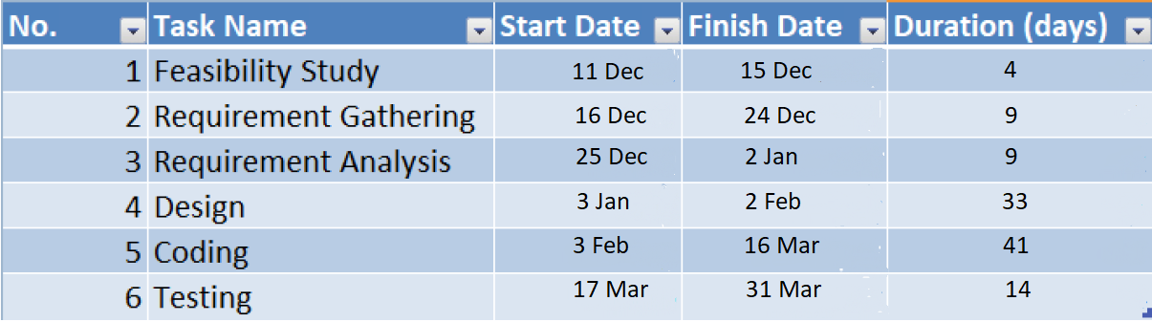

Fig 2.3.1 (Project Scheduling Chart )

Project Management

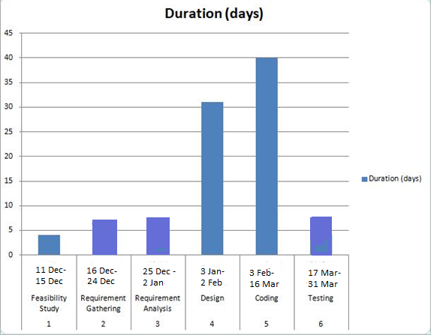

Figure2.3.2 (Gant Chart )

**3.0 SYSTEM REQUIREMENTS STUDY**

**3.1 STUDY OF CURRENT SYSTEM**

Currently company has the manual handling of all accounts for Online Medical Store.

**3.2 PROBLEMS AND WEAKNESSES OF CURRENT SYSTEM**

According to present system we have not kept a faster delivery option which is major thing in buying medicines and there is no manual person to verify prescription, so in that case someone can also do cheating.

**3.3 USER CHARACTERISTICS**

The users using android phones will be able to use our application easily.

**3.4 HARDWARE AND SOFTWARE REQUIREMENTS**

Hardware requirements for using this application are:

* Android Smartphone having

1. 2GB RAM

2. At least 500MB ROM

3. Lowest Android Version supported is 22

4. GPRS Data Plan

5. Location Access or GPS Module (Global Positioning System)

* PC with minimum 4GB RAM and 16GB ROM

System Requirements Study

Software requirements are Android Studio, Google Play Store app with authenticated login to download this application.

**3.5 CONSTRAINTS**

**3.5.1 Regulatory Policies**

As per the Company's policy any developer has to maintain the Coding Standards. Also each and every user should maintain the subversion and commit the modification with appropriate comment so to have track of work and also of the code modification.

From the client’s perspective:

Developer should use well known technology.

Developer should use well known coding standards.

**3.5.2 Hardware Limitations**

The hardware limitation is almost null. The system has been designed according to current OS versions availability which client is using.

From the client’s perspective:

No expectations or requirements need to be fulfilled from the client’s side.

**3.5.3 Parallel Operations**

Multiple parallel operations are executing during the operation of the current application. They might or might not be similar. Hence at the time of concurrency, the FCFS comes into picture. For the rest of the parallel operations except the request for a device by multiple user are all notified to the admin in the formal way of communication i.e. official mail via internal notification systems.

System Requirements Study

**3.5.4 Criticality of the Application**

Criticality means any occurrence of malfunction of the system or any accidental event in software which can damage the resources of software as well as hardware. As per my knowledge there is no criticality in our application.

**3.6 ASSUMPTIONS AND DEPENDENCIES**

**ASSUMPTIONS**

We will provide a user friendly interface so that any user can easily navigate through the system, but he/she should have login name and password for accessing system. The server used for data storing is always secured. Client will provide full details or will purchase any of the license required for 3rd party integration. This is ballpark estimation. It could go higher or lower based on the detail analysis.

Please acknowledge the fact that any feature not covered above would be considered as a change request order. Existing Web service API will be provided by client.

**DEPENDENCIES**

Every new user or organization will receive password via registered email address with the help of which he/she can access the system. All the users of the organization will be assigned a specific set of roles. According to these roles each and every user will be allowed access to a predefined set of features. The features that are assigned to each user will be decided by administrator.

**4.0 SYSTEM ANALYSIS**

**4.1 REQUIREMENTS OF NEW SYSTEM**

**4.1.1 Use Case Diagram**

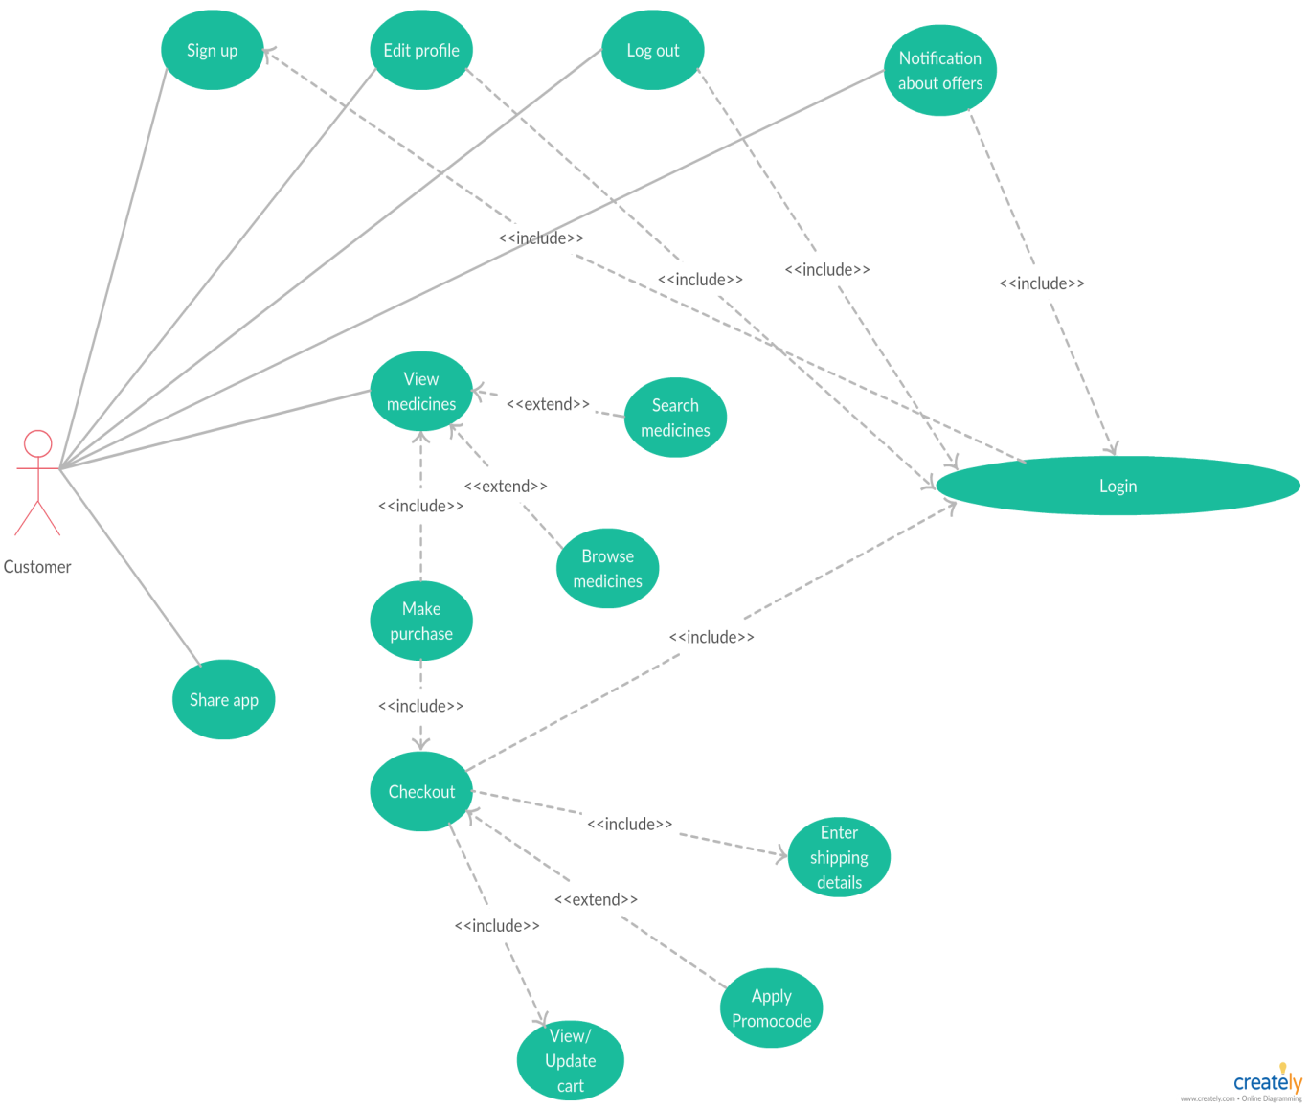

Figure 4.1.1(Use case Diagram)

System Analysis

**4.1.2 System Requirements (SRS)**

**R1: Login**

Input: Enter User Id and Password.

Output: The home page is displayed upon successful login of respected user.

Processing: The user credentials are compared with the one in the database and result is passed on as a message and home page of specific user will be displayed.

**R2: Register**

Input: Enter all details asked in the Register page.

Output: On successfully entering the details, user will be displayed the Login Page.

Processing: The user credentials are validated and then the data will be saved in the database and then user will be asked to enter the User Id and Password in the Login Page.

**R3: Edit Profile**

Input: Enter only those data which is to be edited.

Output: The dialog box showing that data is been edited in the database.

Processing: Entered edited data will be validated and then it will be saved in the database and user will get dialog box showing successful operation.

**R4: View Medicine**

**R4.1: Search Medicines**

System Analysis

Input: Select one of the options from search by product and search by category and then enter the name in the search bar.

Output: The desired result will be displayed.

Processing: Entered Medicine will be compared from the database and will be shown to the customer.

**R4.2: Browse Medicine**

Input: Select one of the options from prescribed or non-prescribed medicines.

Output: Particular Medicines are displayed according to the selected input.

Processing: The selected input is compared with one in the database and result is displayed.

**R5: Upload Prescription**

Input: Select and upload the appropriate prescription file.

Output: The dialog box showing that the prescription has been uploaded successfully.

Processing: The prescription will be saved in the database.

**R6: Place order**

**R6.1: Add to Cart**

Input: Click on the “Add to Cart” button on the product page.

Output: The dialog box showing item is added to the cart and that Medicine will be added to the cart.

Processing: The particular product (medicine) will be updated in the customer’s database.

System Analysis

**R6.2 Apply Promo code**

Input: Enter the valid promo code.

Output: The dialog box showing promo code has been applied after successful verification of that promo code.

Processing: The promo code is compared with the one in the database.

**R6.3 Add Shipping Details**

Input: Enter the shipping details.

Output: The order page is displayed after entering the details.

Processing: The details will be updated in the customer’s database.

**R6.3 Place Order**

Input: Select place order option on the shopping cart screen.

Output: The dialog box showing order has been placed.

Processing: The particular product (medicine) will be updated in the customer’s database.

**R7: Check Notification**

Input: The logged in user can check his /her notification bar whenever he/she wanted to. No specific input needed from user side, user just needed to be online.

Output: The dialog box showing any new or unread notification available.

Processing: Based on user event and database related update linked to any push notification, respective user will be notified.

System Analysis

**R8: Logout**

Input: Select the logout option.

Output: User will be logged out from the account.

Processing: Once the user selects the logout option the session will be closed.

**Non Functional Requirements**

The Non Functional Requirements are as follows: -

Correctness.

Authentication.

Plagiarism checking.

Maintainability.

Integrity.

Efficiency.

**4.2 Features of New System**

* Easy to use.
* Reliable and accurate.
* Better UI and better interaction.
* Maintainability.
* Reliability.
* Availability.
* Portability.

System Analysis

**4.3 SYSTEM ACTIVITY DIAGRAM**

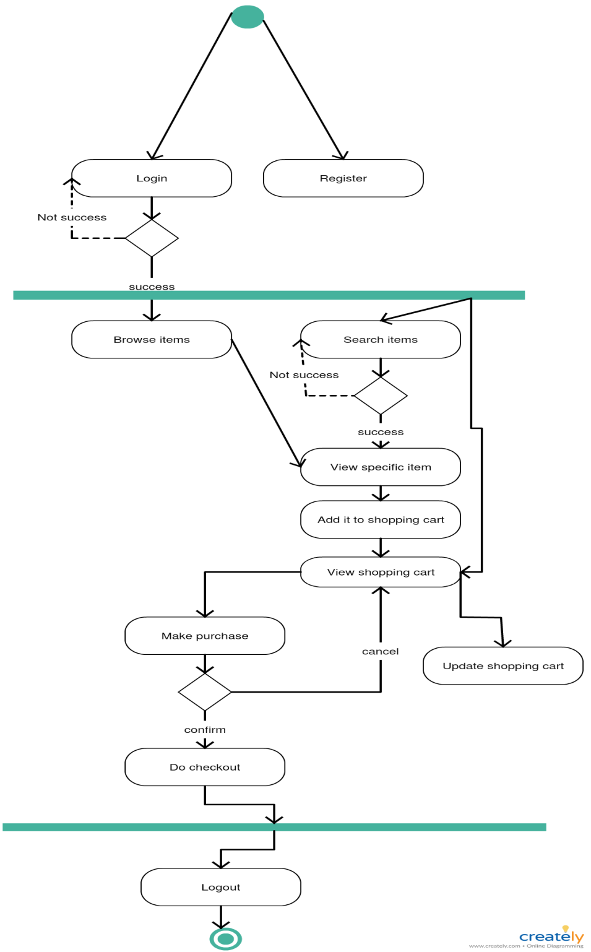

Figure 4.3(Activity Diagram)

System Analysis

**4.4 DATA MODELLING**

**ER Diagram**

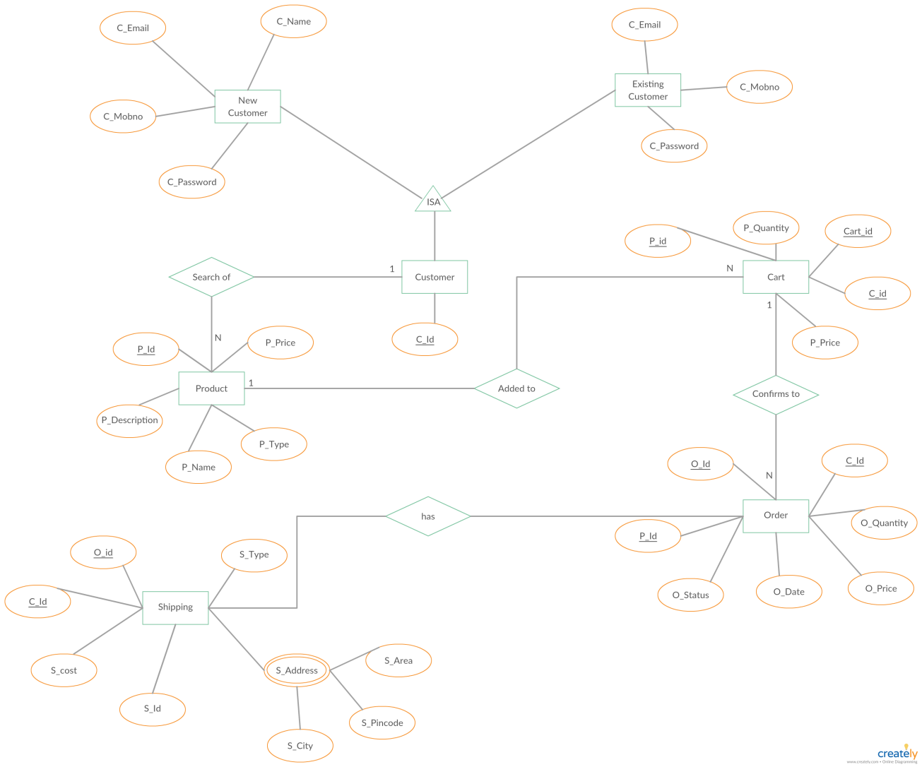

Figure 4.4(E-R Diagram)

**5.0 SYSTEM DESIGN**

**5.1 SYSTEM ARCHITECTURE DESIGN**

**5.1.1Class Diagram**

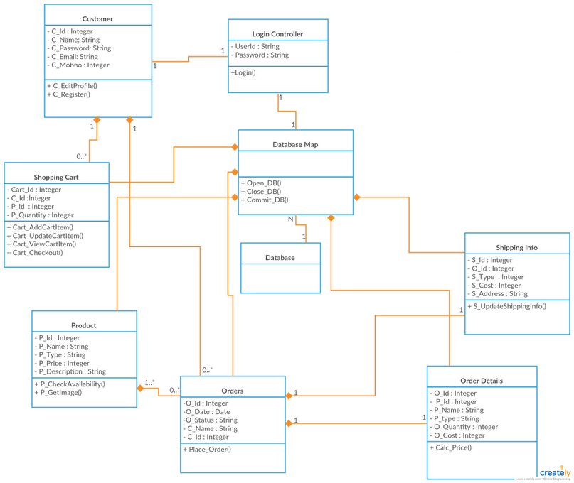

Figure 5.2.1(Class Diagram)

System Design

**5.2 SEQUENCE DIAGRAM:**

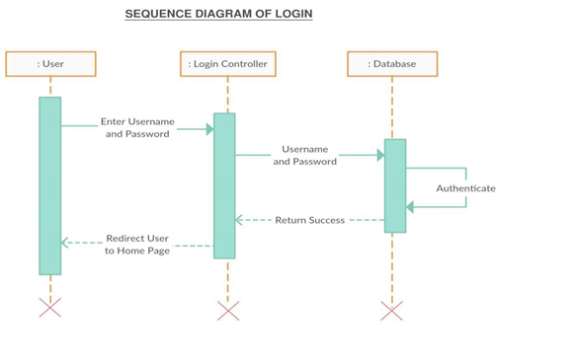 Figure 5.2.1(Sequence Diagram of login)

**SEQUENCE DIAGRAM OF SIGNUP**

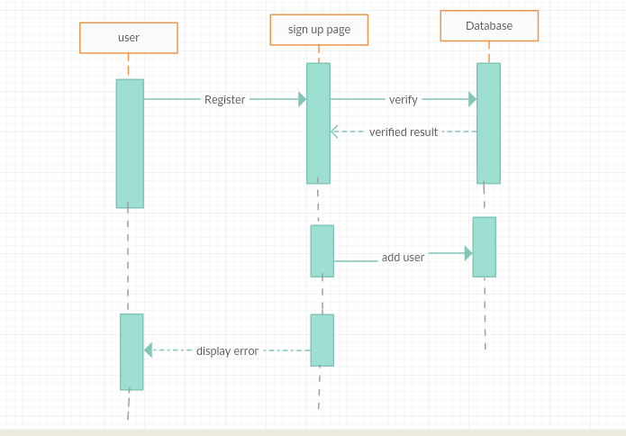

Fig 5.2.2(Sequence Diagram of Sign up)

System Design

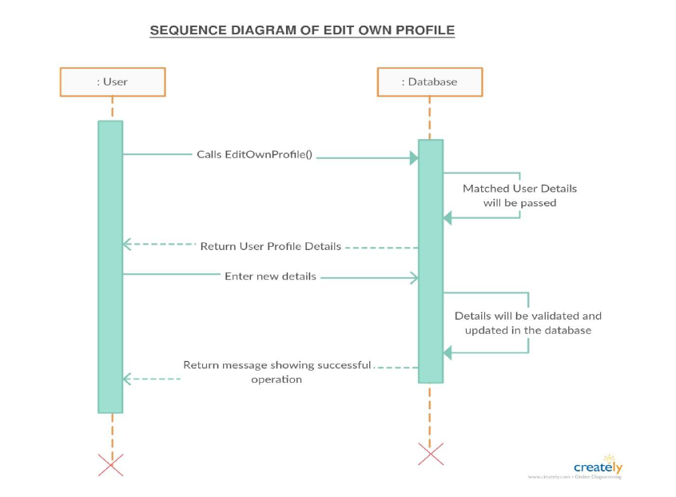

Figure 5.2.3(Sequence Diagram of Edit Profile)

**SEQUENCE DIAGRAM OF ORDER**

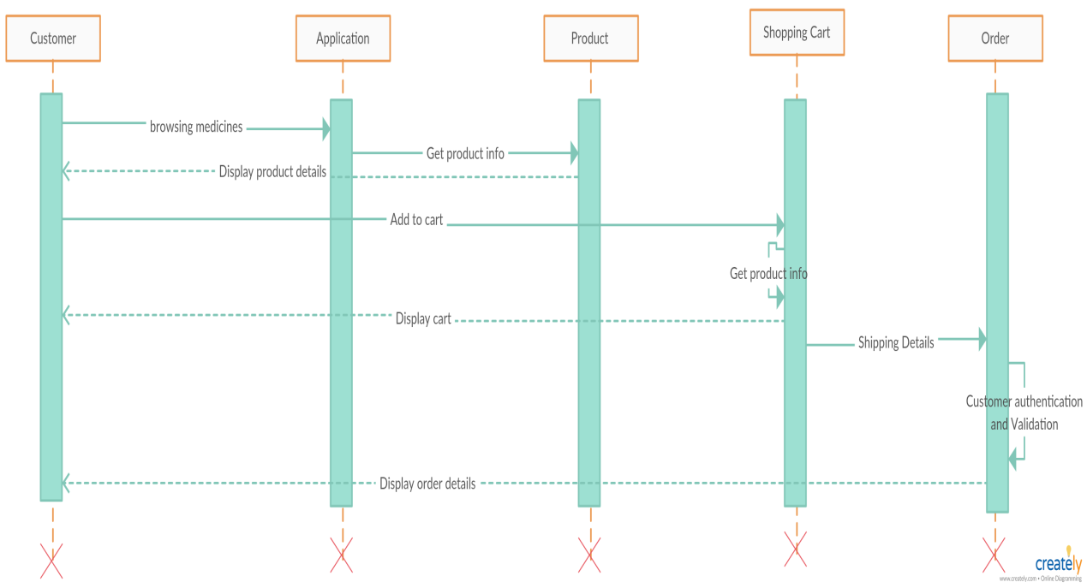

Figure 5.2.4(Sequence Diagram of Order)

System Design

**5.3 COMPONENT DIAGRAM**

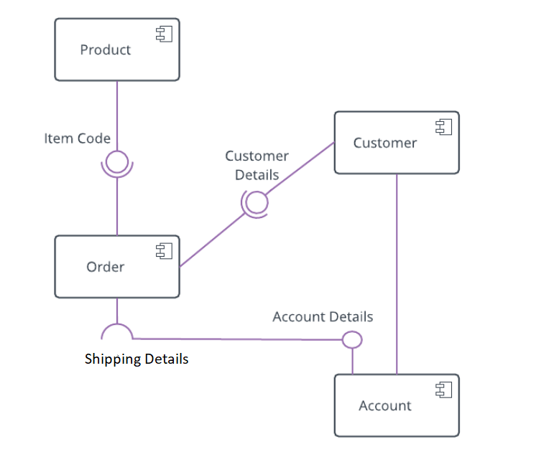

Figure5.3.1 (Component Diagram)

**5.4 DEPLOYMENT DIAGRAM**

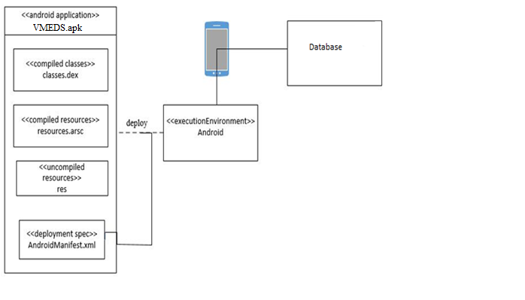

Figure5.4.1 (Deployment Diagram)

**6.0 IMPLEMENTATION PLANNING**

**6.1 IMPLEMENTATION ENVIRONMENT**

Multi-user vs. Single-user:

Single user applications are the application where it is useful to only one user at a time. While in Multi user application is used by many users at the same time and thus application are used by many users at the same time. Our system is a multi-user system as we have more than one user who can use the system at a same time.

GUI vs. Non-GUI:

Non GUI application uses command Prompt for input and output while GUI application has graphics form to interface and other graphics property for various I/O operation and are easy to use. Our System is a GUI based and thus easy and effective to use therefore user can easily give input and take Output.

**6.2 MODULES SPECIFICATION**

Login and Logout Module

Get location module

Enable track module

View on map module

Add user module

Get direction module

**6.3 CODING STANDARDS**

Coding Standards contribute to an improved comprehension of source code. Perhaps one of the most influential aids to understanding the logical flow of an application is how the various elements of the application are named. A name should tell "what"

Implementation Planning

rather than "how." By avoiding names that expose the underlying implementation, which can change, you preserve a layer of abstraction that simplifies the complexity.

Naming Conventions make programs more understandable by making them easier to read. They can also give information about the function of the identifier – for example, whether it’s a constant, class, etc. which can be helpful in understanding the code.

Reasons for using the coding standards are

Uniform distribution, Sound understanding, Encourages Good programming skills. All code -should be well commented. All procedures and functions should begin with a comment to explain what the function/procedure performs. Good and meaningful comments make code more maintainable. Do not write comments for every line of code and every variable defined. Write comments wherever required. But good readable code will require very less comments. If all the variables and methods names are meaningful, that would make the code very readable and will not need more comments.

**7.0 TESTING**

**7.1 TESTING PLAN**

Testing is the process carried out on software to detect the differences between its behavior and the desired behavior as stipulated by the requirements specifications. Testing is advantageous in several ways.  Firstly, the defects found help to correct, testing gives an idea as to how reliable the software is.  Thirdly, over time, the record of defects found reveals the most common kinds of defects, which can be used for developing appropriate preventive measures such as training, proper design and reviewing.

Software testing is the critical element of the software quality assurance and represents the ultimate review of specification, design, and code generation. Once the source code has been generated, software must be tested to uncover as many errors as possible before delivery to the users. This chapter describes some of the testing techniques for designing tests that:

Exercise the internal logic of the software components

Exercise the input and output domains of the program to uncover errors in program function, behavior and performance.

The testing sub-process includes the following activities in a phase dependent manner:

Create Test Plans.

Create Test Specifications.

Review Test Plans and Test Specifications.

Conduct tests according to the Test Specifications, and log the defects.

Fix defects, if any.

When defects are fixed continue from activity.

The need for Testing:

No matter how good a programmer is no application will never be one hundred percent correct. Testing was important to us in order to ensure that the application

Testing

Works as efficient as possible and conforms to the needs of the system. Testing was carried out throughout the development of the application, not just the application has

been developed, as at this stage it took a great deal of effort to fix any bugs or design problems that were occurred.

**7.2 TESTING STRATEGY**

Once source code has been generated, software must be tested to uncover as many errors as possible before delivery to customer. Your goal is to design a series of test cases that have a high likelihood of finding errors. Software testing techniques provide systematic guidance for designing tests that (1) exercise the internal logic of software components, and (2) exercise the inputs and outputs domains of the program to uncover errors in program function, behaviour and performance. During early stages of testing, a software engineer performs all tests. However, as the testing process progresses, testing specialists may become involved. Reviews and other activities can and do uncover errors, but they are not sufficient. Every time the program is executed, the customer tests it! Therefore, you have to execute the program before it gets to the customer with the specific intent of finding and removing all errors. In order to find the highest possible number of errors, tests must be conducted systematically and test cases must be designed using disciplined techniques.

Testing Objective:

Testing is a process of executing a program with the intention of finding an error. A good test case is one that has a high probability of finding an as-yet undiscovered error. A successful test is one that uncover an as-yet undiscovered error.

**7.2.1 Unit Testing**

Unit testing is a software development process in which the smallest testable part of an application, called units, is individually scrutinized for proper operation. Unit testing is often automated but it can also be done manually. This testing mode is a

Testing

component of Extreme Programming (XP), a pragmatic method of software development that takes a meticulous approach to building a product by means of continual testing and revision. Unit testing involves only those characteristics that are vital to the performance of the unit under test. This encourages developer to modify the source code without immediate concerns about how such changes might affect the functioning of the units or the program as a whole. Once of whole of the units in a program have been found to be working in the most efficient and error free manner possible, larger components of the program can be evaluated by means of integration testing. I tested each single part of the entire application. I tested each and every module individually. On user side tested modules like Selection of Difficulty levels, Selection of a new game, resuming to the last saved game, the information display as well as the grid generation part. Similarly, for every module I have done Unit testing while coding and before submitting a demo. So, most of the errors have been removed from the website**.**

**7.2.2 Sub System Testing**

After testing each unit, we move on to larger units called sub system. In subsystem testing I tested the whole user side as one system. On the user side all the modules like continue game, start new game and select difficulty level, etc. were tested together to see if there was any error or bug found.

**7.2.3 System Testing**

After testing all the sub-system, it is time to test the whole system. System testing of software is testing conducted on a complete, integrated system to evaluate the system compliance with its specified requirements. While testing the whole system I found many errors like the toasts stayed for a higher amount of time leading to difficulties in inputs. I solved it by making appropriate changes in the duration of toast as well as changed its visibility properties. I worked on each error and exception that I got while

Testing

testing and most of them are removed or made such correction that it will not happen again. Recovery Testing: It is a system test that forces the software to fail in a variety of ways and verifies that recovery is properly performed. Security Testing: It attempts to verify that protection mechanisms build into a system will, in fact, protect it from improper penetration.

Performance Testing: It is designed to test the run-time performance of software within the context of an integrated system performance testing occurs throughout all step in the testing process.

**7.2.4 Acceptance Testing**

Acceptance testing can be connected by the end user, customer, or client to validate whether or not to accept the product. Acceptance testing may be performed as part of the hand-off process between any two phases of development. The acceptance test suite is run again the supplied input data or using an acceptance test script to direct the tester. Then the results obtained are compared with the expected results. If there is a correct match for every case, the test suite is said to pass.

**7.3 TESTING METHODS**

The verification activities fall into the category of static testing. During static testing, you have a checklist to check whether the work you are doing is going as per the set standards of the organization. These standards can be for coding, integrating and deployment. Reviews, Inspection’s and Walkthroughs are static testing methodologist. Dynamic testing involves working with the software giving input values and checking if the output is as expected. These are the validation activities. Unit test, integration test, System and acceptance tests are few of the dynamic testing methodologies. Alpha & beta testing: the alpha test is conducted at the developer’s site by a customer. The software is used in a natural setting with the developer

Testing

“looking over shoulder” of the user and recording errors and usage problems. Alpha test are conducted in a controlled environment. The beta testing is conducted at one or more customer site by the end-user of the software. Unlike alpha testing, the developer is generally not present. Therefore, the beta test is a “live” application of the software in an environment that cannot be controlled by the developer.

**7.3.1 Black box testing**

Also known as functional testing.A software testing techniques where by the internal working of the item being tested are not known by the tester. For example, in a black box test on software design the tester only knows the inputs and what the expected outcomes should be and not how the program arrives at those outputs. The tester does not ever examine the programming code and does not need any further knowledge of the program other than its specification. The advantages of this type of testing include: The test is unbiased as the designer and the tester are independent of each other. The tester does not need knowledge of any specific programming languages .The test is done from the point of view of the user, not the designer .Test cases can be designed as soon as the specifications are complete.

The disadvantages of this type of testing include: The test can be redundant if the software designer has already run a test case. The test cases are difficult to design. Testing every possible input stream is unrealistic because it would take an inordinate amount of time: hence many program paths will go untested

**7.3.2 White box testing**

Also known as glass box, structural, clear box and open box testing. A software testing technique where by explicit knowledge of the internal workings of the item being tested are used to select the test data. Unlike black box testing, white box testing uses specific knowledge of programming code to examine outputs. The test is accurate only if the tester knows what the program is supposed to do. He or she can than see if the program diverges from its intended goal.

Testing

**7.3.3 Design of test Cases**

To minimize the number of errors in software, a rich variety of test design methods have evolved for software. These methods provide the developer with a systematic approach to testing. More important, methods provide a mechanism that can help to ensure the completeness of test and provide the highest likelihood for uncovering errors in software. An engineering product can be tested in one of the two ways: (1) knowing the specified function that product has been designed to perform, tests can be conducted that demonstrate each function is fully operational while at the same time searching for errors in each function: (2) knowing the internal workings of a product, tests can be conducted to ensure that “all gear mesh“, that is, internal oppression are performed according to specifications and all internal components have been adequately exercised. Here are the test cases that we had made for our application.

**7.4 TEST CASES**

**Test Case for login:**

|  |  |  |  |
| --- | --- | --- | --- |
| No. | Test Case | Expected Result | Test Result |
| 1 | Blank username/ Mob no | Pop up at a particular field | Pass |
| 2 | Blank password | Pop up at a particular field | Pass |
| 3 | Incorrect username or password | Error message displayed | Pass |
| 4 | Correct username and password | Main page is displayed | Pass |

Table 7.4.1

**Test case for Registration:**

|  |  |  |  |
| --- | --- | --- | --- |
| No. | Test case | Expected result | Test result |
| 1 | Blank fields | Pop up at particular field | Pass |
| 2 | Validation for various fields | If failed-  Pop up at a particular field  Else-  Render to home page | Pass |

Table 7.4.2

**Test case for edit profile:**

|  |  |  |  |
| --- | --- | --- | --- |
| No. | Test Case | Expected Result | Test Result |
| 1 | Name | The changed name is saved in the database. | Pass |
| 2 | Password | The changed password is saved in the database. | Pass |
| 3 | Email | The changed email is saved in the database. | Pass |
| 4 | Mob no | The changed mob no is saved in the database. | Pass |

Table 7.4.3

**Important Test Cases:**

|  |  |  |  |
| --- | --- | --- | --- |
| No. | Test case | Expected result | Test result |
| 1 | Click on “Search” icon from home page | The particular medicine that you have search for either product by category or product by name is displayed on the screen | Pass |
| 2 | Click on “Add to Cart” icon on the particular product page. | The product on which “Add to Cart” icon is clicked is added to the cart. | Pass |
| 3 | Click on “place order” button in the cart. | The product has been ordered. | Pass |
| 4 | Click on “delete button” in the cart. | The particular product has been removed from the cart. | Pass |
| 5 | Click on “offers” tab on the home page. | The offers page is displayed with available notifications. | Pass |
| 6 | Click on “notifications” tab on the home page. | The notifications page is displayed with notifications that are sent to you. | Pass |
| 7 | Open application without internet. | A pop up is displayed with “No internet connection” and we can’t go further in application. | Pass |
| 8 | Click on “Share app” button in navigation drawer. | A pop up is displayed with different options to share the application. | Pass |
| 9 | Click on description on the particular product page. | The screen showing detailed description of product is displayed | Pass |
| 10 | Click on the prescribed/daily products on the home screen. | The different sub-categories of prescribed/daily products are displayed. | Pass |
| 11 | Click on “my orders” from the navigation drawer | All the placed orders are displayed. | Pass |
| 12 | Click on “my cart” from the navigation drawer | All the products in the cart are displayed. | Pass |

Table 7.4.4

**8.0 USER MANUAL**

**SCREENSHOTS**

The User manual acts an interface between the developer and the user to help the user use the application to suit his needs and requirements. The manual shows the look and feel of the application and pictorially guides the user for the normal course of operation of the application.

**SPLASH SCREEN:-**



Figure8.1 (Splash screen)

* This screen will be displayed when the user clicks on the VMEDS application icon.

User Manual

**HOME PAGE:-**

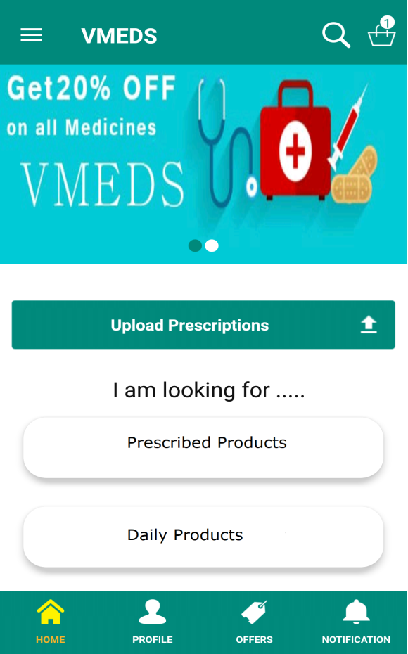 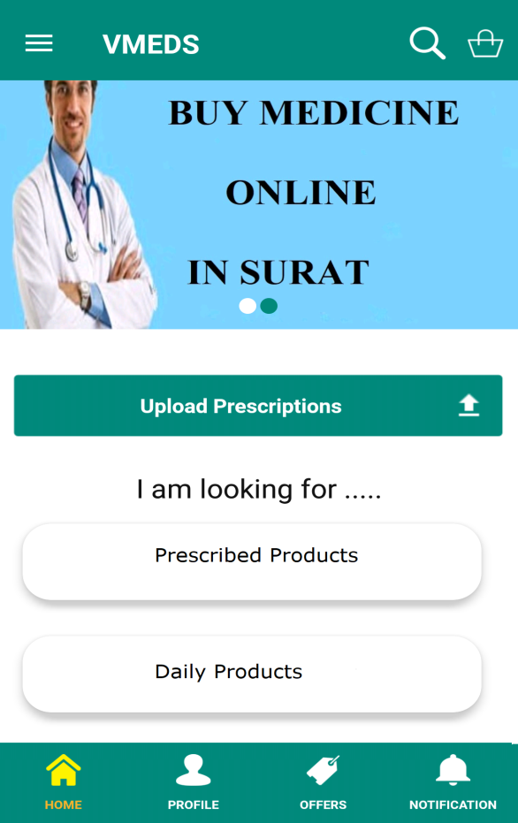

Figure8.2 (Home screen) Figure8.3 (Home screen)

* This is the home page of the application from where the user can navigate to entire application.
* A user can search for medicines or can browse other medicines. User can also access profile, offers and notification pages from the home page.
* User can also access cart from top right corner and there are other options in the navigation drawer.

User Manual

**NAVIGATION DRAWER:-**

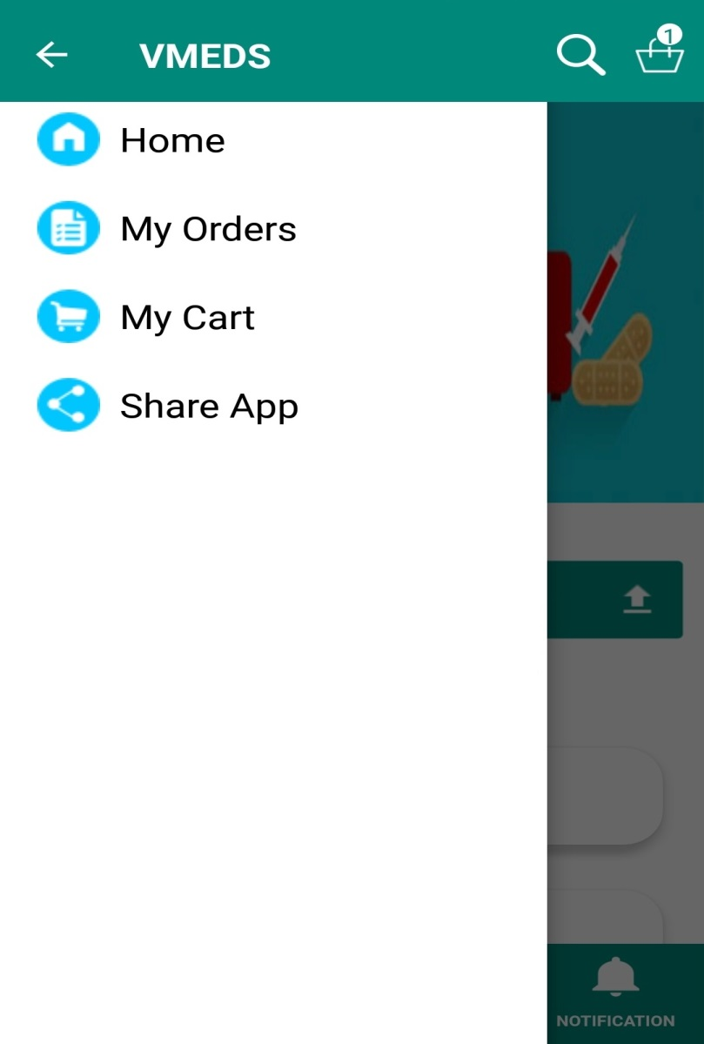

Figure8.4 (Navigation drawer)

* It appears on clicking the three line button on the top left corner of the home page.
* It contains Home, My Orders, My Cart and Share app. From navigation drawer user can choose from one of these options available.

User Manual

**LOGIN PAGE:-**

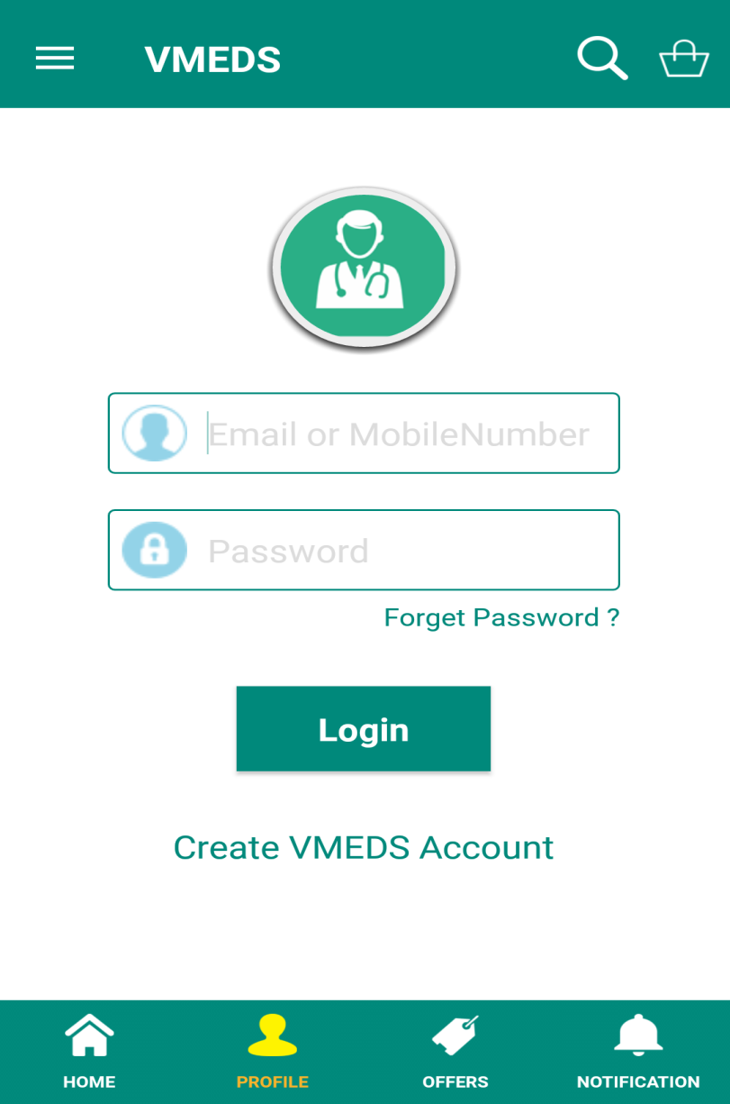

Figure8.5 (Login screen)

* This is the Login Page where user has to enter valid email/mob no and password to login into his/her account.
* There is also an option of forget password in case if the user forgets the password.
* If the user is not registered yet, this page also has a option that takes you to the registration page.

User Manual

**SIGN UP PAGE:-**

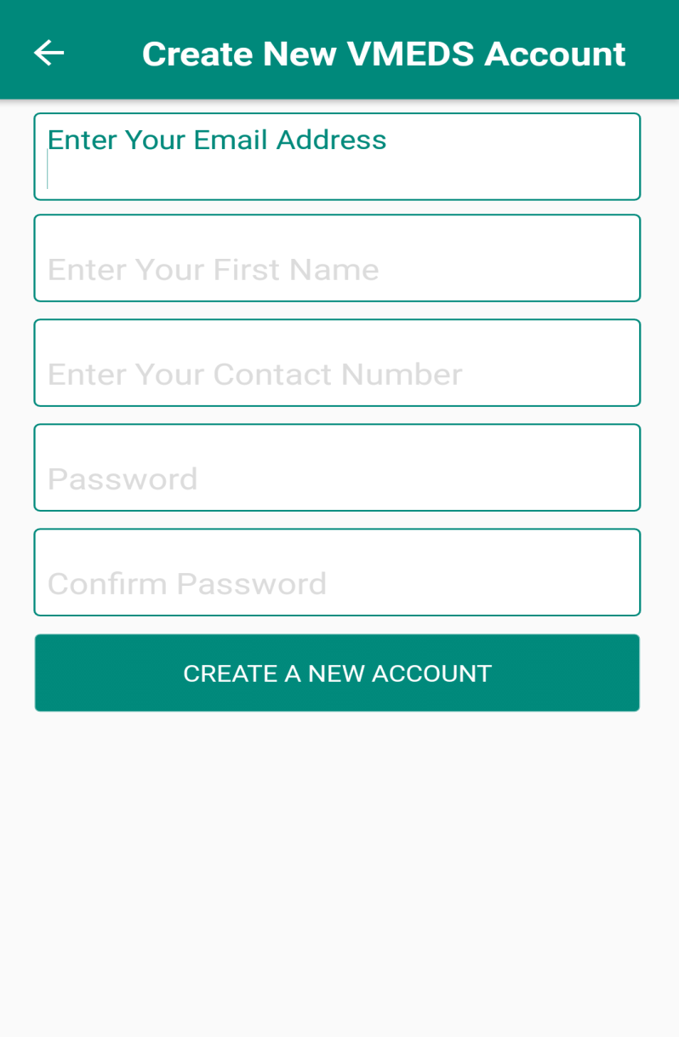

Figure8.6 (Sign up)

* This is Sign up page where user will enter details and gets registered with the application and then he/she can login in the application.

User Manual

**SEARCH MEDICINES:-**

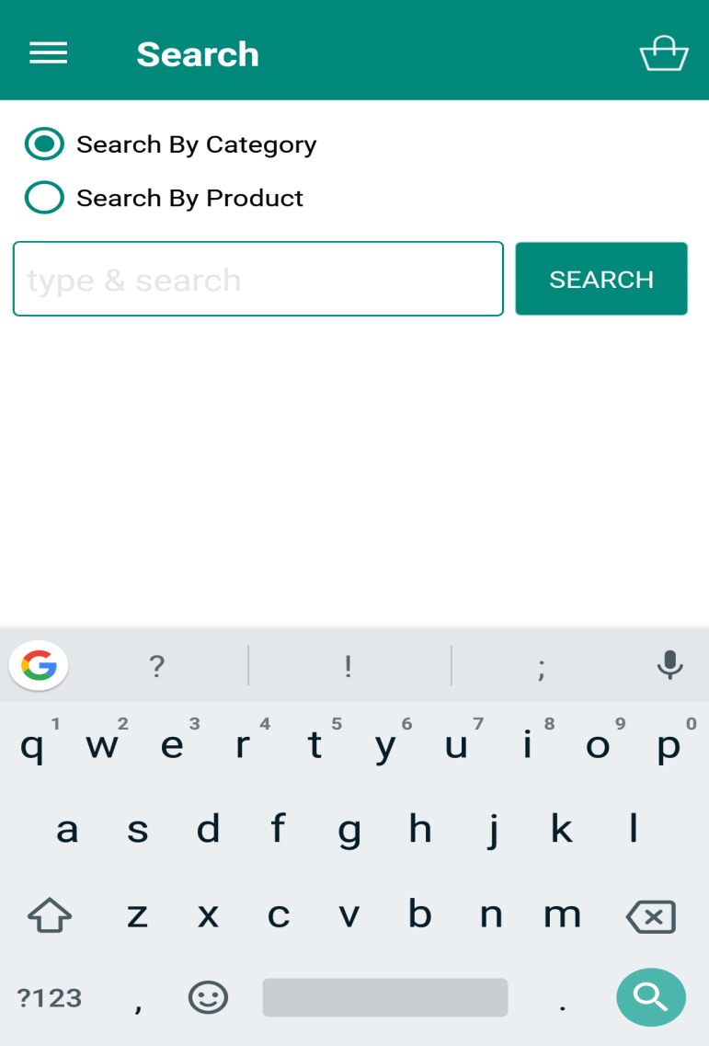

Figure8.7 (search screen)

* This is the page where user can search medicines.
* User has two options. He/she can either search by product or search by category.

User Manual

**USER PROFILE:-**

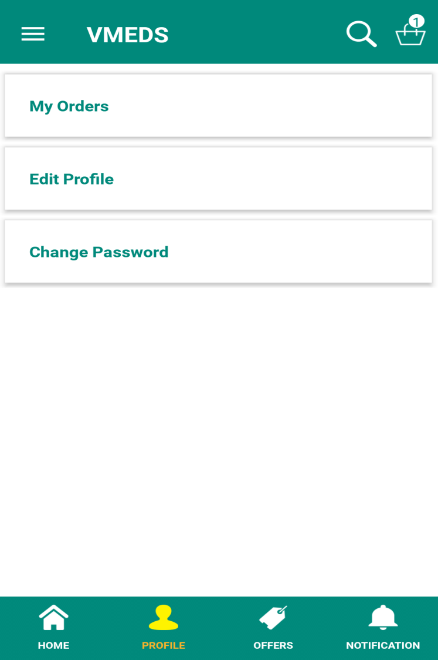

Figure8.8 (user profile)

* This is the user’s profile. A user can see all the orders from here. A user can also edit his profile and can also change his/hers account password from the profile.

User Manual

**EDIT PROFILE:-**

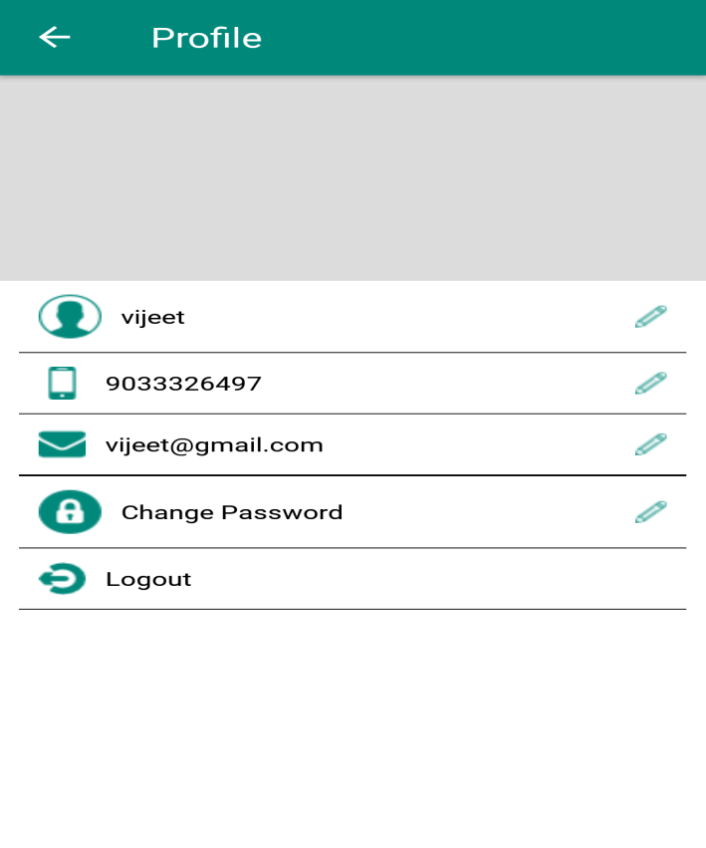 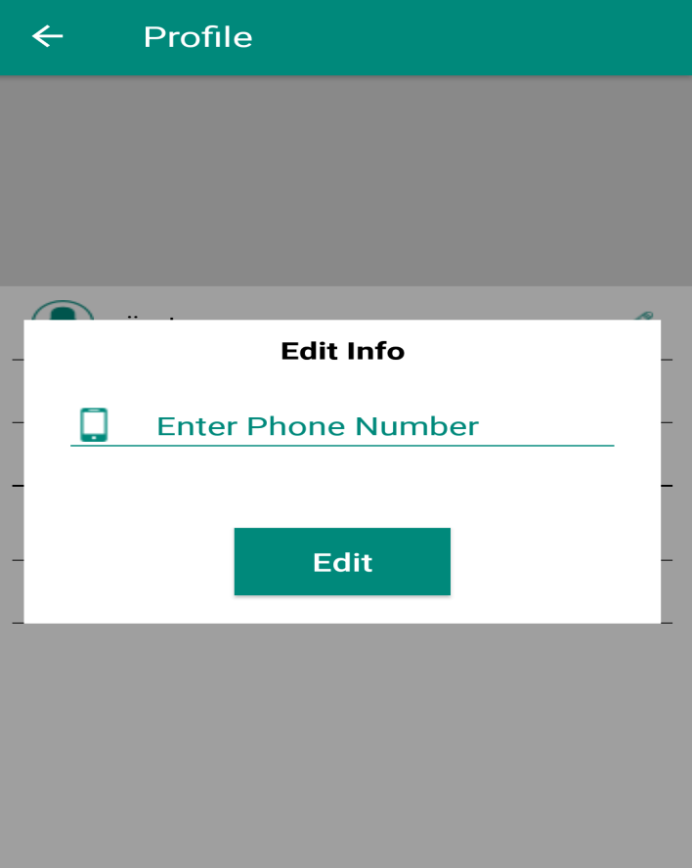

Figure8.9 (Edit profile) Figure8.10 (Edit profile)

* This is the Edit Profile Page from where user can edit name, mob no, email id and password.
* Users also have an option to logout from his account.

User Manual

**FORGOT PASSWORD:-**

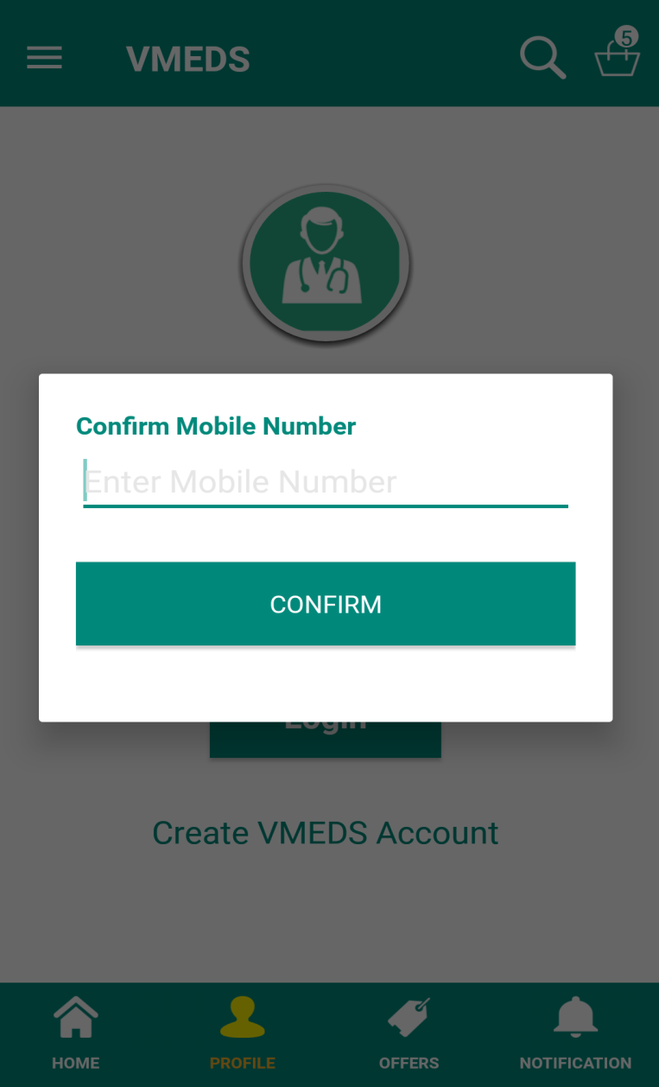

Figure8.11 (Forgot Password)

* While logging if the user forgets the password, he can use forgot password option.
* On clicking on forgot password option, user has to enter his mob no so that an otp will be send on that entered mob no to reset the password.

User Manual

**OFFERS PAGE:-**

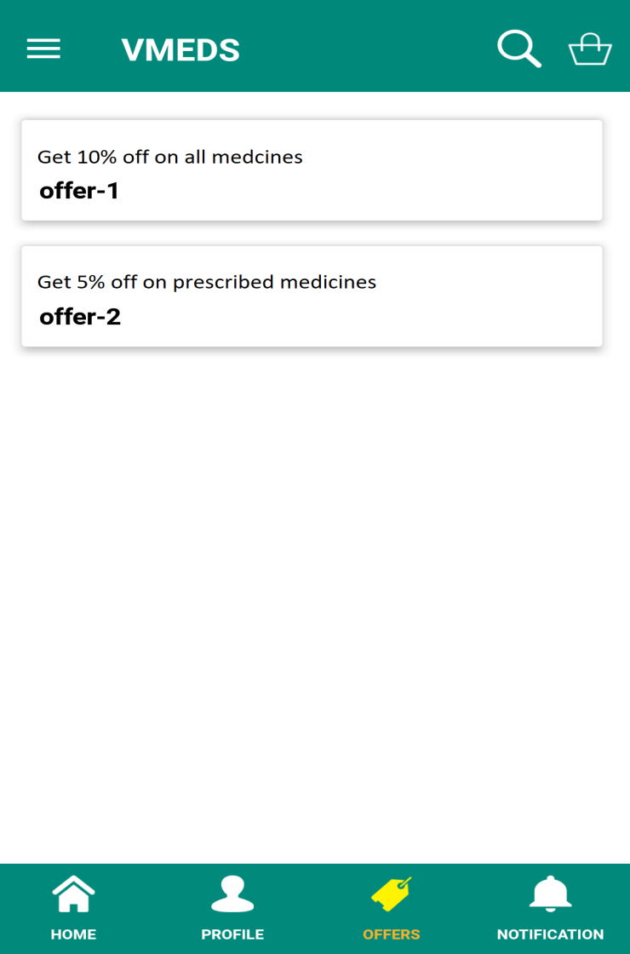

Figure8.12 (Offers screen)

* This is the offers page where user can see all the available offers so that he/she can use those offers and can get benefited.

User Manual

**NOTIFICATION PAGE:-**

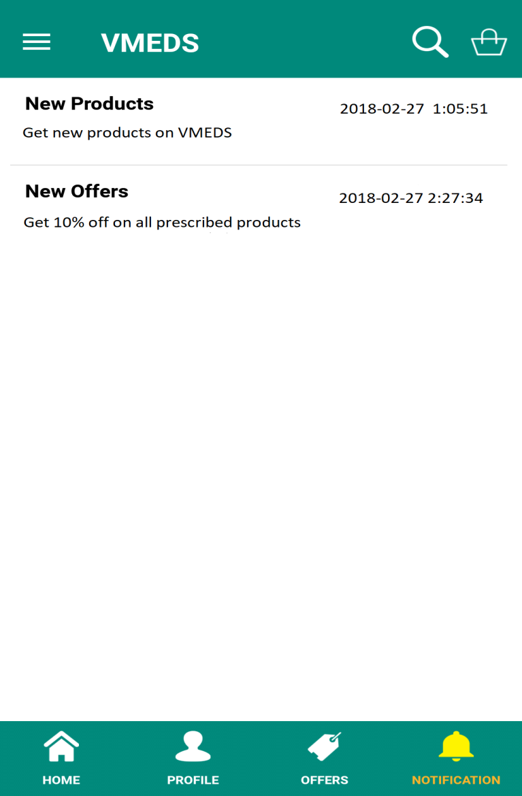

Figure8.13 (Notification screen)

* This is the notification page where user will see all the notifications that has been sent to him/her.

User Manual

**VIEW MEDICINE:-**

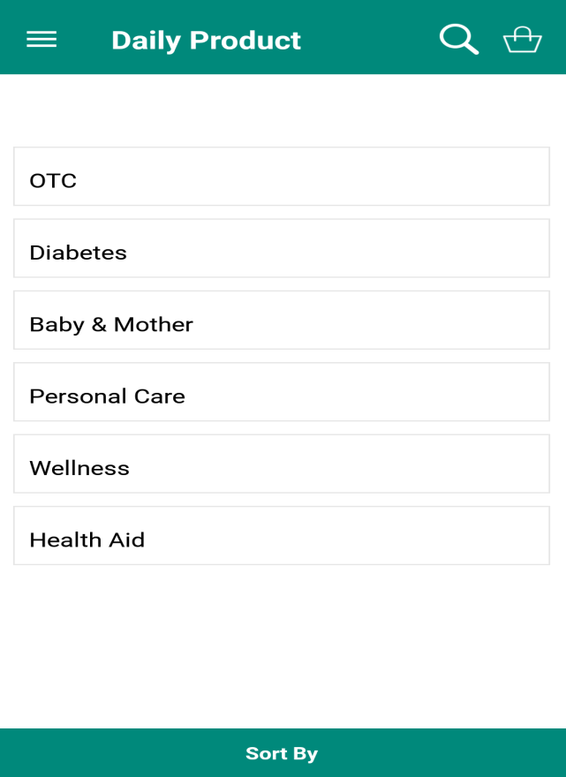

Figure8.14 (View medicine)

* User has two options to view or browse medicines. i) Prescribed products and ii) Daily products.
* After selecting prescribed or daily products, it is further categorised into different categories like OTC, diabetes, Personal Care, Allergies etc.

User Manual

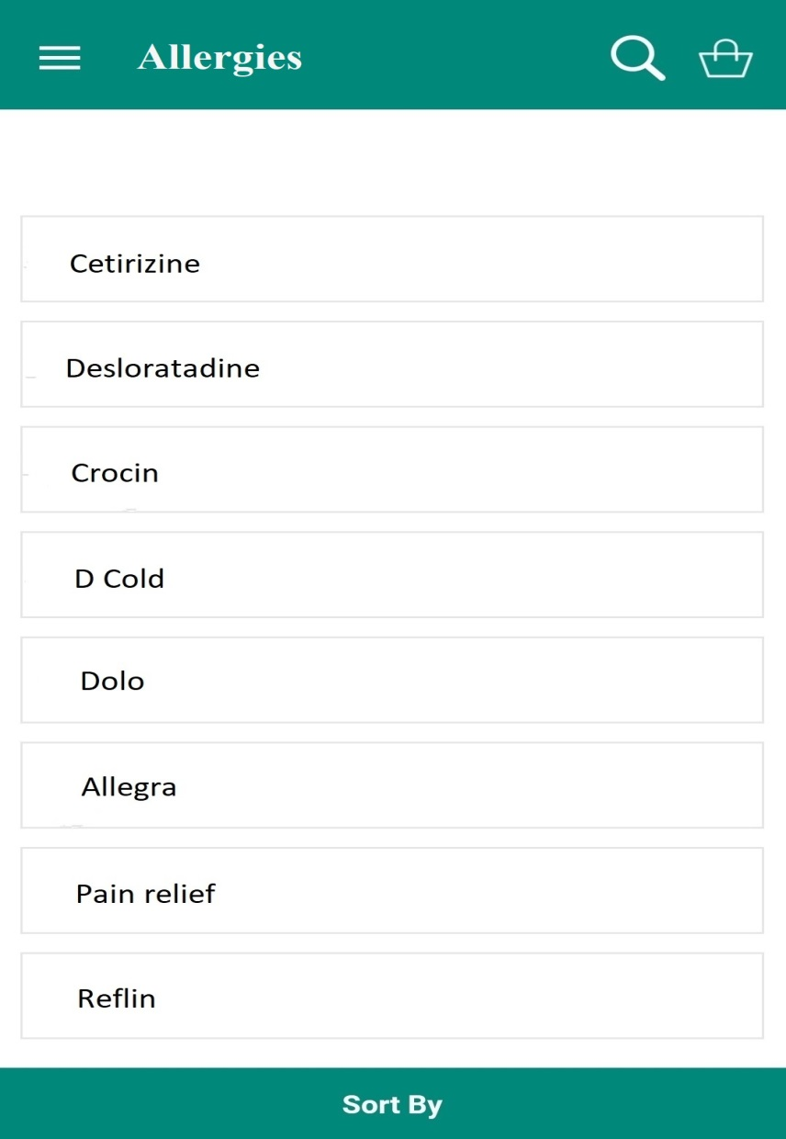

Figure8.15 (Prescribed medicines)

* After selecting one of the categories from prescribed or daily products, it shows the different available medicines of that category i.e. Allergies category is selected from Daily products, so the available medicines of allergies will appear.

User Manual

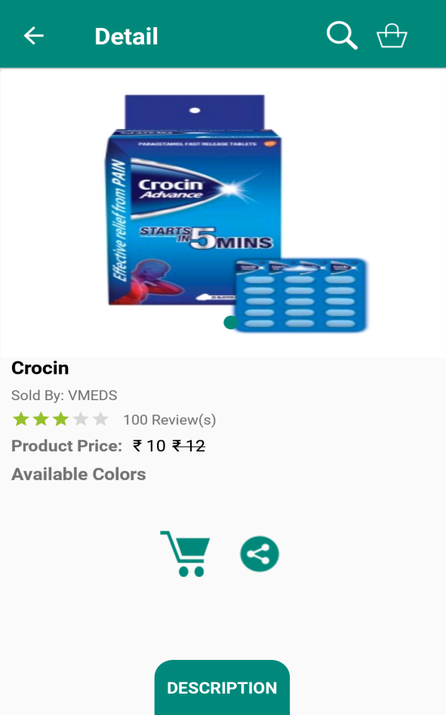 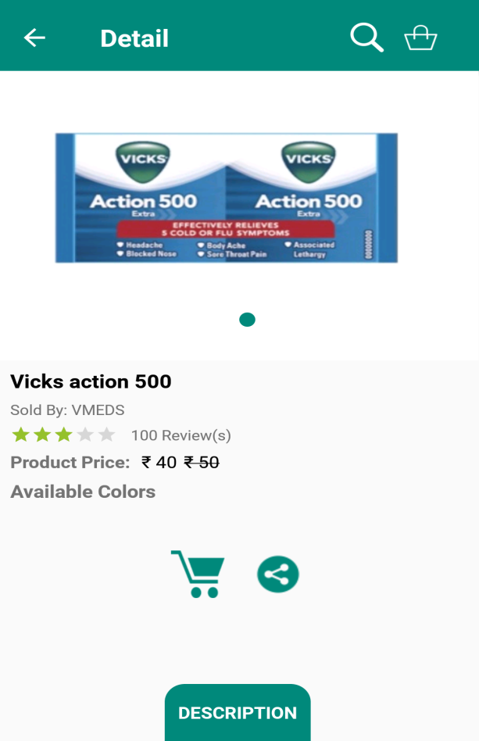

Figure8.16 (product page) Figure8.17 (product page)

* After selection one of the medicines, the final medicine page appears as shown above.
* User has an option to add the particular medicine to the cart. User can also share this product with others.
* User can also see the full description of the product by clicking on description button at bottom.

User Manual

.

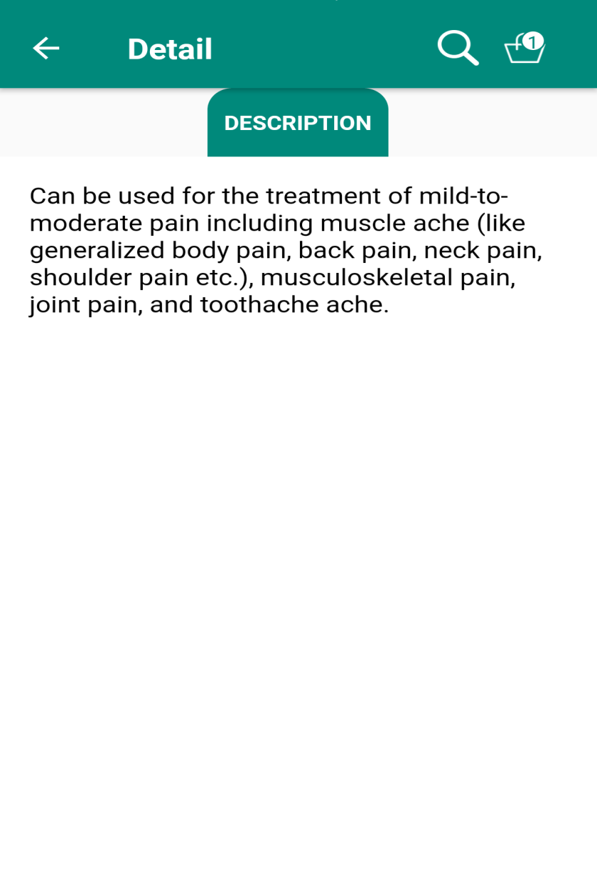

Figure8.18 (Description screen)

* After selecting one of the medicines we can see as shown in the above images. When description is clicked, it will give the detail description of that medicine.

User Manual

**CART:-**

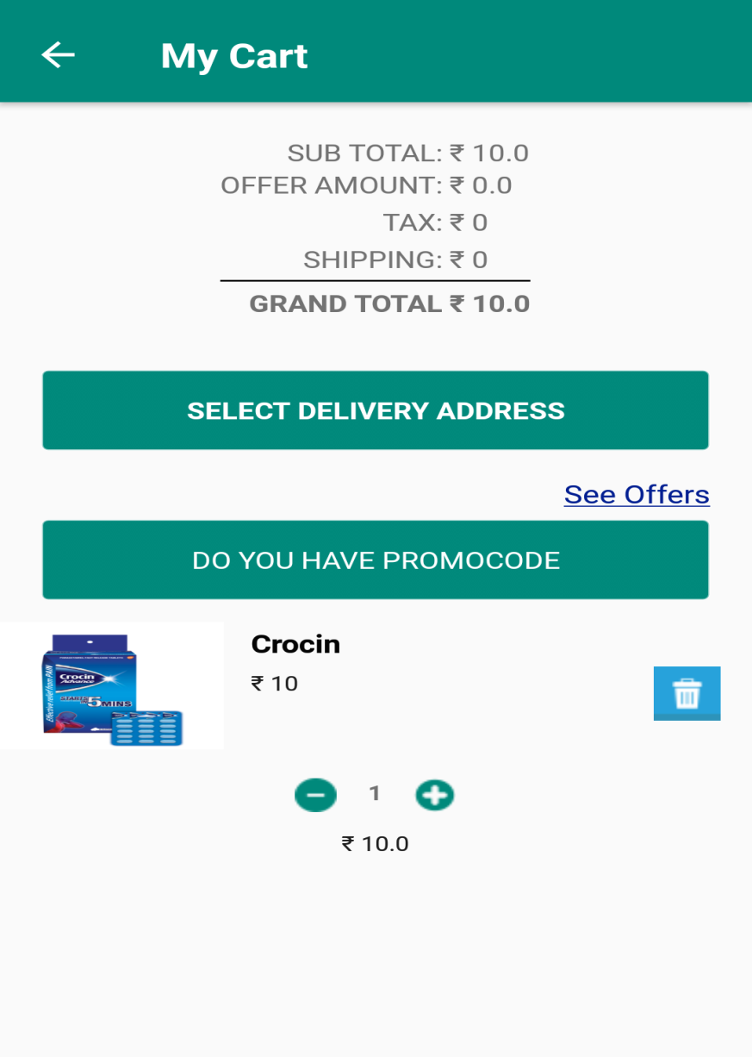

Figure8.19 (Shopping cart)

* User can increase or decrease the quantity of product by clicking on “+” or “-” button in the cart.
* User can remove the product by clicking on remove button. He can also apply available promocodes.
* To place the order user has to click on “select delivery address” and fill the shipping details and then order will be placed.

User Manual

**SHIPPING DETAILS:-**

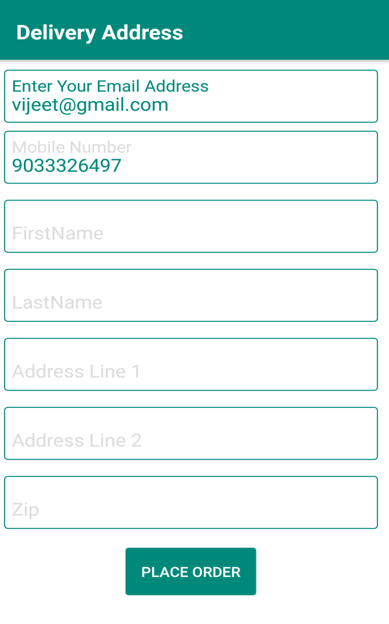

Figure8.20 (shipping details)

* To place an order fill all the necessary shipping details and then the order will be placed.

User Manual

**ORDER SUMMARY:-**

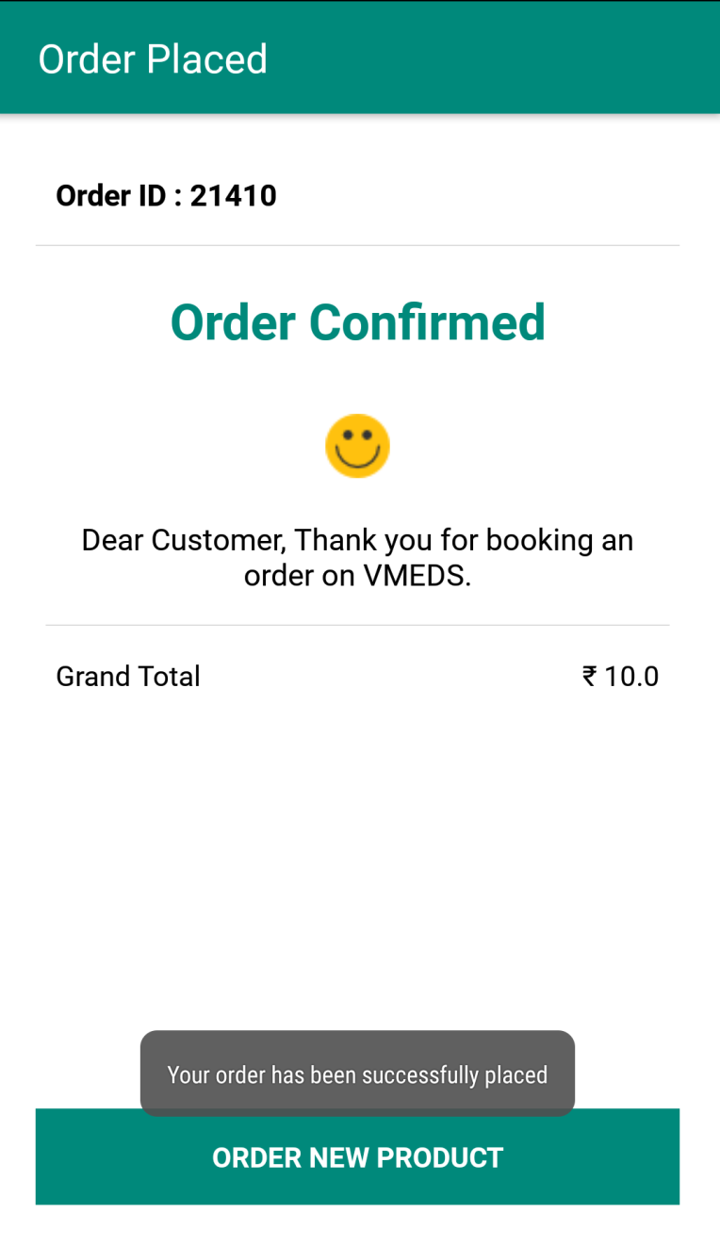

Figure8.21 (Order summary)

* After clicking on place order in the shipping details page, order will be placed and order summary is shown as described in the above image.
* There is an option “order new product” on the page. After clicking on that option, user is redirected to the home page so that user can place other orders.

User Manual

**MY ORDERS PAGE:-**

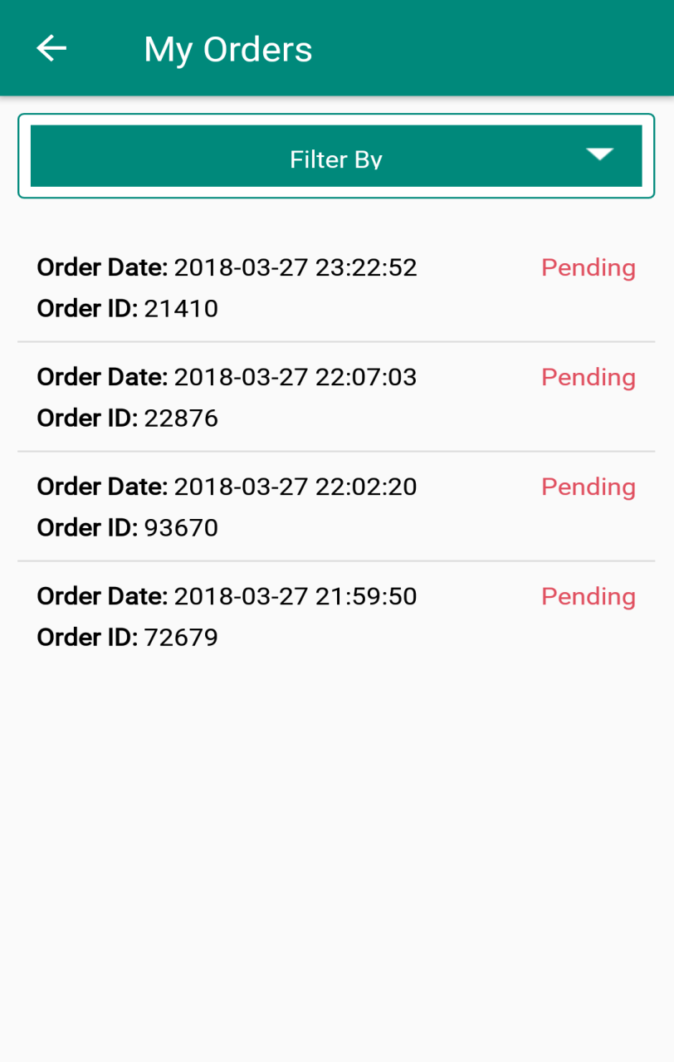

Figure8.22 (My orders)

* After clicking on my orders from navigation drawer or user’s profile, it shows all the orders user has placed.
* It shows the order id, order date and the order status.
* After the clicking on one of the orders, it will display all the information about that order.

User Manual

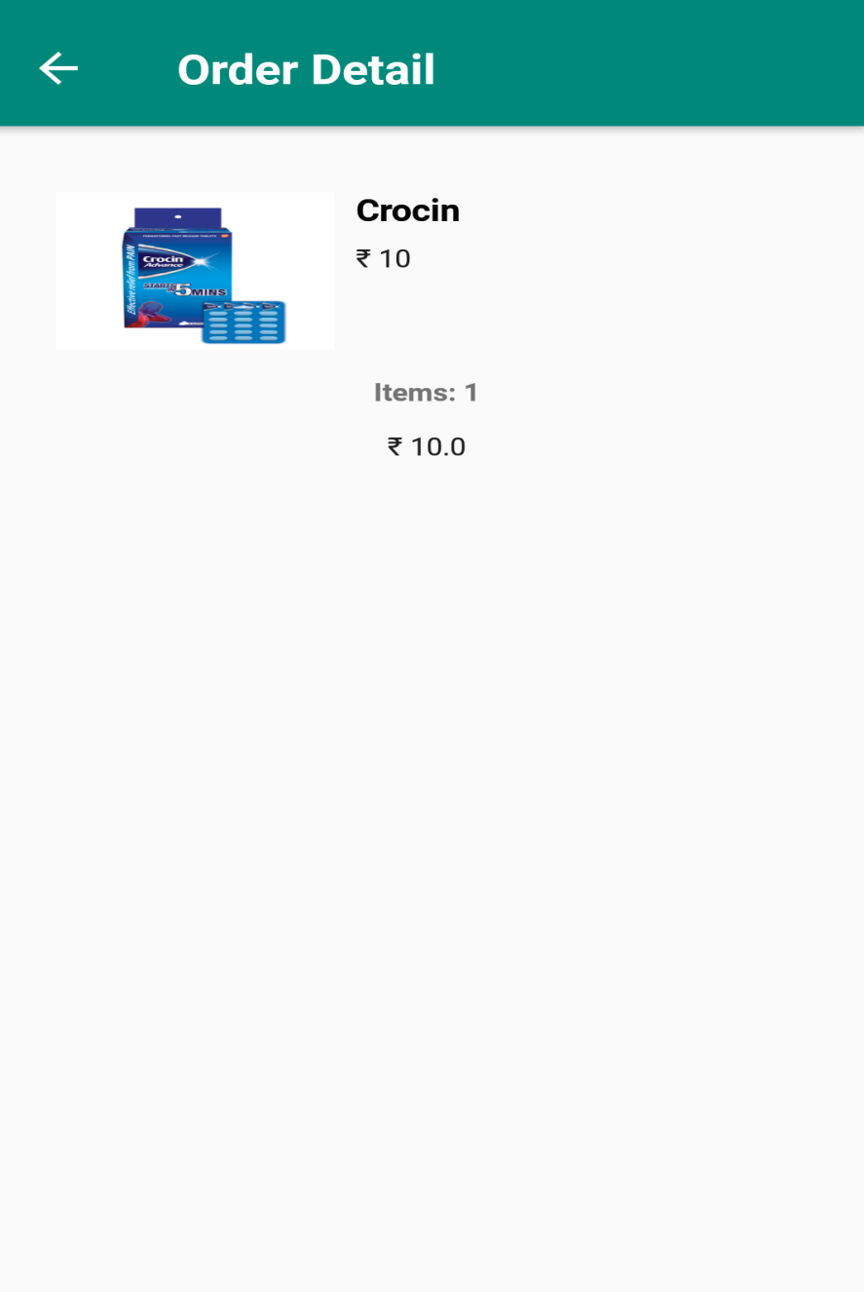

Figure8.23 (Order detail)

* After clicking on particular order on the “my orders” page it will show all the details of that order as shown above.

**9.0 LIMITATION AND FUTURE ENHANCEMENT**

**9.1 LIMITATION**

The limitations of my application are:

1. Phone must have internet connection on.
2. User cannot do online payment.
3. Application size is comparatively bigger than other applications.

**9.2 FUTURE ENHANCEMENT**

1. In future, we like to have a wish list feature in which user can save his favourite products.

2. We will also implement payment options and third party applications for payment.

3. We like to have faster delivery options for emergency.

4. In case if a medicine is not available we like to have a substitutes option so that customer can purchase medicines.

**10.0 CONCLUSION AND DISCUSSION**

**10.1 CONCLUSION**

The Online Medical Store has been developed by me through applying my knowledge gained from some other systems, refereeing to certain books, browsing some sites and through the help of faculties and my industrial guide.

No project can be termed as “Perfect” in real sense and there always remains scope for further improvements that leads to develop a next higher version.

I would like to thank the project guides that extends all their support and helped me to complete this project successfully.

**10.2 DISCUSSION**

**10.2.1 Self Analysis and Project Viability**

According to me, this project is completed with the primary functionalities as specified earlier but then again there is lot more than this which can be done. The project is well capable to handle the given job for the required tasks. The full-fledged project would soon be available on the internet, from where all the learner and faculty can use.

**10.2.2 Problem Encountered and Possible Solution**

There were some problems that were encountered while developing the application:

* Problem maintaining such a large database.

Conclusion and Discussion

* First problem I faced in Android concepts were new to me. By making demo application and using online material to study Android and with help of my project guide I solved it.
* Moreover the lack of practical know-how of these aspects did cause a few hindrances in early stages of training.
* It was a solo project so I didn't get any chance of brainstorming so I have to do lots of research and it cost me such a great time and I learnt a lot from this experience.

**10.2.3 Summary of Project Work**

I have completed my project work using software engineering and system analysis and design approach following the spiral model for software development. I have done my work with planned scheduling pertaining the time constraints and result oriented progress in project development.

**REFERENCES**

[1] Mike van Drongelen, Android *Studio Cookbook*, Packt Publishing.

[2] Neil Smyth, *Android Studio Development Essentials - Android 6 Edition*, CreateSpace Independent Publishing Platform.

[3] https://developer.android.com/studio/intro/index.html

[4] https://github.com/

[5] https://www.javatpoint.com/java/

[6] https://www.javaworld.com/article/3095406/android/android-studio-for-beginners-part-1-installation-and-setup.html

[7] https://stackoverflow.com/

[8] http://www.tutorialspoint.com/android/android_studio.htm

[9] https://www.tutorialspoint.com/android/android/ecommerce/order.htm

[10] https://www.tutorialspoint.com/android/android_add_to_cart.htm

[11] https://www.tutorialspoint.com/android/android_user_interface_layouts.htm

[12] https://en.wikipedia.org/wiki/Android_Studio

[13] https://www.youtube.com/user/akshayejh

**EXPERIENCE**

It has been a wonderful experience working at Neeasoft IT Services Pvt .Ltd. I am grateful to all our mentors and colleagues for guiding me throughout the project. My mentors not only supported me but also taught me various things that will be very helpful for me in future.

I got exposure of how an actual software firm works. It played on my strengths as a learner and the company had this application needed to be developed. It not only improved my technical skills but it also ameliorated my communication skill. It was amazing working in a team with so friendly and helpful employees of Neeasoft IT Services Pvt .Ltd. It made me more punctual and improved my time management skills. I also learnt how to cope up with deadlines. My mentor was extremely altruistic and he motivated me during each phase of developing our android application. The place had a very friendly environment and gave us a positive attitude for working. Yes, They have offered me a job.